**Volunteer Impact Collaboration Network (VICN)**

**Target Users:** NGO Staff, Volunteer Coordinators, Volunteers, Donors

**Problem Statement ❗**

NGOs rely heavily on volunteers for initiatives like blood donation camps, food drives, awareness events, and fundraising. However, most NGOs still depend on manual methods (Excel sheets, phone calls, WhatsApp groups), which causes challenges:

* Difficulty in maintaining updated records of volunteer skills, availability, and past contributions.
* Lack of reminders, thank-you notes, or recognition, leading to low engagement.
* Limited visibility into volunteer hours, participation, or retention.
* Missed opportunities to identify and retain active volunteers.
* Event scheduling and communication require multiple apps (Google Calendar, emails, WhatsApp)

**Proposed Solution: Volunteer Impact Collaboration Network**

A Salesforce-powered platform designed to strengthen NGO–volunteer collaboration by:

* Centralizing volunteer profiles, skills, and availability.
* Automating reminders, thank-you messages, and onboarding emails.
* Tracking volunteer hours, event participation, and retention.
* Providing dashboards for impact measurement and decision-making.

**Phase 1: Problem Understanding & Industry Analysis**

**Requirement Gathering**

* Maintain detailed volunteer profiles (skills, availability, past participation).
* Create and manage events with location, type, and schedule.
* Enable volunteer self-registration or admin-based assignment.
* Record participation hours and collect feedback.
* Generate dashboards for active vs. inactive volunteers, total hours, and participation trends.

**Functional Requirements**

1. **Volunteer Profile Management**
   * The system shall allow adding, editing, and deleting volunteer profiles.
   * The system shall store volunteer details (name, contact, skills, availability).
   * The system shall allow searching/filtering volunteers by skill and availability.
2. **Event Management**
   * The system shall allow creation and management of events (name, date, location, type).
   * The system shall allow assigning or self-registering volunteers for events.
   * The system shall allow viewing upcoming and past events.
3. **Participation Tracking**
   * The system shall record volunteer attendance and total hours contributed.
   * The system shall allow storing event feedback and comments.
4. **Automation of Communication**
   * The system shall send a welcome email upon volunteer registration.
   * The system shall send reminders before an event.
   * The system shall send thank-you messages after an event.
5. **Reports & Dashboards**
   * The system shall display active vs. inactive volunteers.
   * The system shall show total volunteer hours and event participation.
   * The system shall allow exporting reports in CSV/PDF format.

**Non-Functional Requirements**

1. **Performance** – The system shall load pages within 3 seconds.
2. **Security** – The system shall protect data with SSL and role-based access.
3. **Usability** – The system shall provide a simple and responsive UI.
4. **Reliability** – The system shall maintain 99.5% uptime with daily backups.
5. **Scalability** – The system shall support growing numbers of volunteers/events.
6. **Maintainability** – The system shall be modular and well-documented.

**Stakeholder Analysis**

* **Admin (NGO Staff):** Creates volunteer/event records, manages automations & security.
* **Volunteer Coordinator:** Assigns volunteers, tracks hours, reviews engagement.
* **Volunteer:** Registers, participates, receives reminders & thank-you messages.
* **System (Automation):** Sends communications, updates statuses, generates dashboards.

**Business Process Mapping**

1. **Volunteer Registration** → Volunteer signs up → system stores details → welcome email sent.
2. **Event Creation** → NGO staff create events → synced with Google Calendar → notifications sent.
3. **Volunteer Participation** → Volunteers view/register → system tracks attendance & hours.
4. **Post-Event Actions** → Personalized thank-you messages sent → impact reports generated.
5. **Smart Recommendations** → AI suggests engagement actions for inactive volunteers.

**Use Cases**

**Blood Donation Camp**

* **Challenge:** Manual notifications are slow and inefficient.
* **Solution:** Automated SMS/email alerts based on volunteer availability & past history.

**Environmental Cleanup Drive**

* **Challenge:** No centralized tracking of hours or cleaned locations.
* **Solution:** Volunteers log hours → system generates impact analytics.

**Educational Training for Underprivileged Children**

* **Challenge:** Hard to monitor attendance & effectiveness.
* **Solution:** Self-registration → automatic attendance tracking → performance insights.

**AppExchange Exploration**

* **Volunteer Applications:** Structured volunteer profile & participation management.
* **Marketing Automation:** Event invites, reminders, thank-you campaigns.
* **Calendar Integration:** Unified calendar view of upcoming events.
* **Analytics & Insights:** Dashboards for trends, engagement, and AI-driven recommendations.

**Competitor Landscape**

| **Competitor** | **Strengths** | **Weaknesses / Gaps** | **Differentiation Opportunity** |
| --- | --- | --- | --- |
| **Volunteers for Salesforce (V4S)** | - Native Salesforce app, widely adopted - Handles basic volunteer sign-up & event tracking - Free and backed by Salesforce.org | - Outdated UI, limited customization - Reporting is not intuitive - No smart engagement features (AI, re-engagement suggestions) | - Modern, AI-powered volunteer engagement - Smart dashboards & automation |
| **Third-Party Volunteer Apps (e.g., Golden Volunteer, HandsOn Connect)** | - Rich features: mobile apps, volunteer matching, scheduling - Proven track record with large nonprofits | - Expensive licensing - Integration with Salesforce often requires custom connectors - Can create data silos outside Salesforce | - Native Salesforce-first experience - Seamless data flow without costly integrations |
| **Generic CRM Add-ons (Calendar & Event Tools)** | - Good for scheduling & calendar visualization - Flexible across industries | - Not purpose-built for NGOs/volunteers - Lack of impact tracking (hours, contribution value) | - Focus on volunteer impact analytics - Effortless reporting for nonprofits |

**Phase 2: Org Setup & Configuration**

**Company Profile Setup**

Configured organization details to establish VICN’s Salesforce environment:

* **Path:** Setup → Company Information → Edit
* **Organization Name:** VICN -Volunteer Collaboration Impact Network
* **Time Zone:** (GMT+05:30) Asia/Kolkata
* **Locale:** English (India)
* **Language:** English
* **Currency:** INR (Indian Rupee) – with option to add USD later for global NGO partnerships.

**Purpose:**  
Defines the organization’s base settings such as locale, currency, and timezone for consistent reporting and automation across all modules.

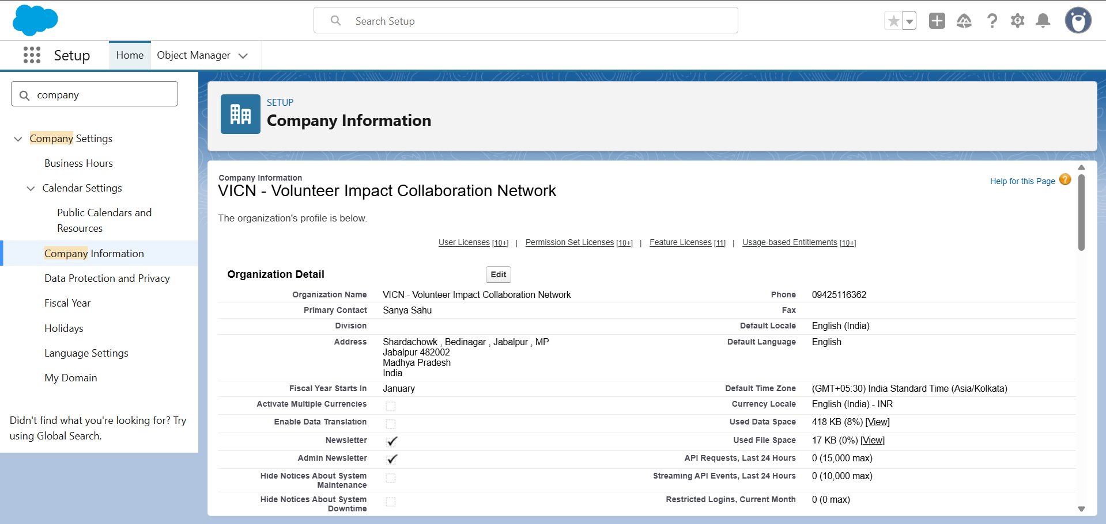

**Business Hours Setup**

Defined VICN’s standard working hours to align with volunteer scheduling and event management:

* **Path:** Setup → Business Hours → New
* **Name:** VICN Standard Working Hours
* **Time Zone:** (GMT+05:30) Asia/Kolkata
* **Working Days:** Monday to Friday
* **Working Hours:** 9:00 AM – 6:00 PM
* **Save:** Marked as default for the organization.

**Purpose:**  
Ensures automations, reminders, and case escalations follow realistic NGO working schedules.

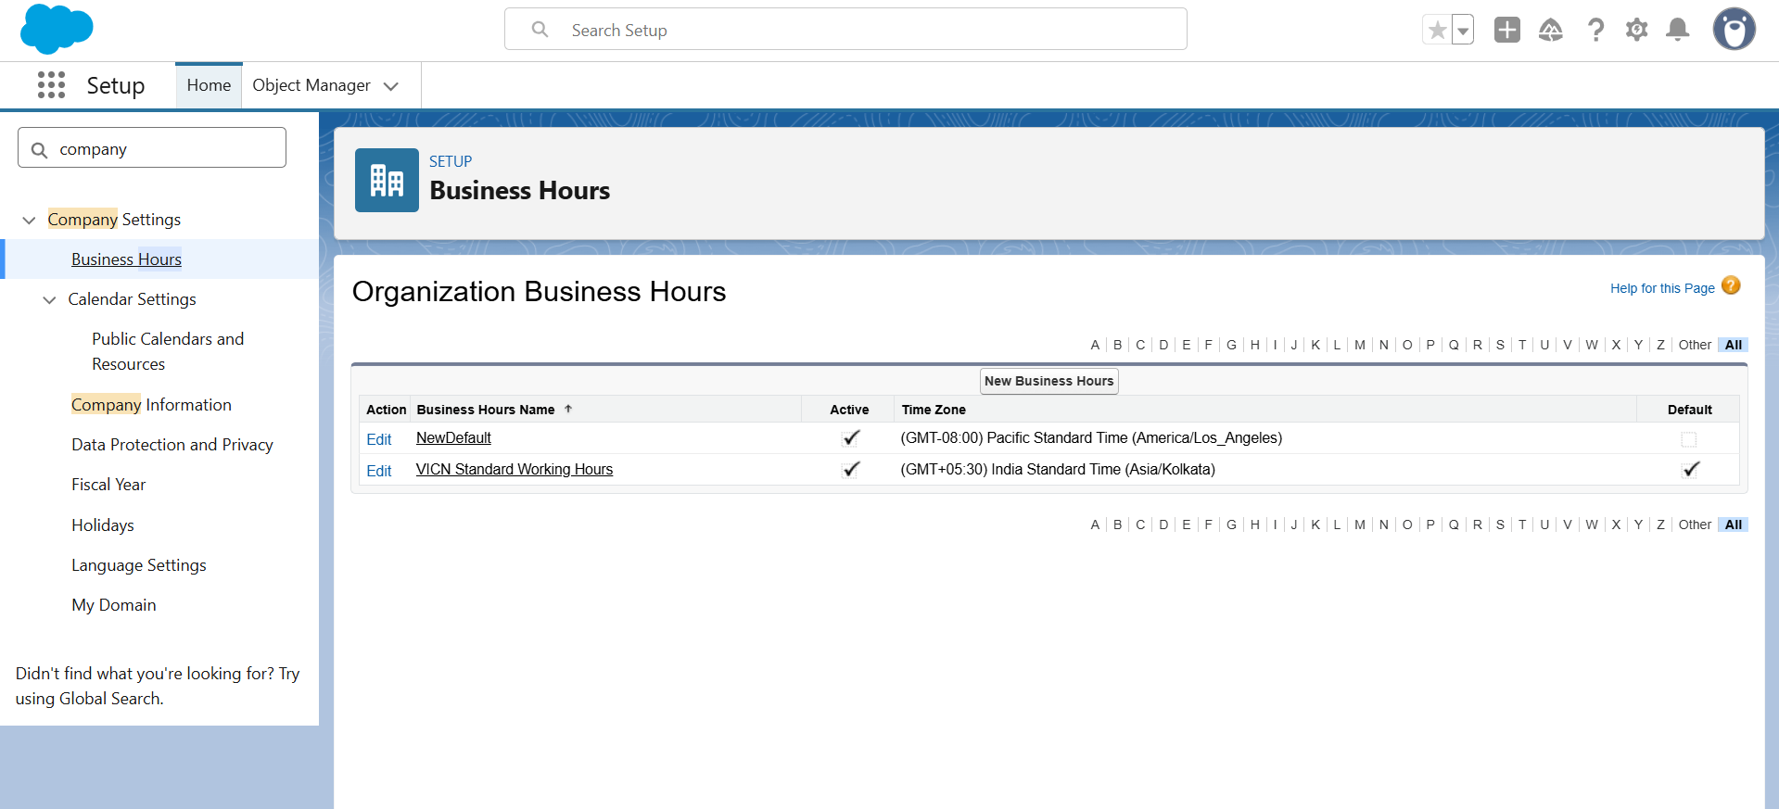

**Holidays Setup**

Added key national holidays to prevent event scheduling conflicts and ensure volunteer availability is accurately tracked.

* **Path:** Setup → Holidays → New

1. New Year – **1 January** (Recurring: Yes)
2. Gandhi Jayanti – **2 October** (Recurring: Yes)
3. Christmas – **25 December** (Recurring: Yes)..so on

**Purpose:**  
Holidays integrate with Business Hours to pause SLAs, automated reminders, and event notifications during non-working days.

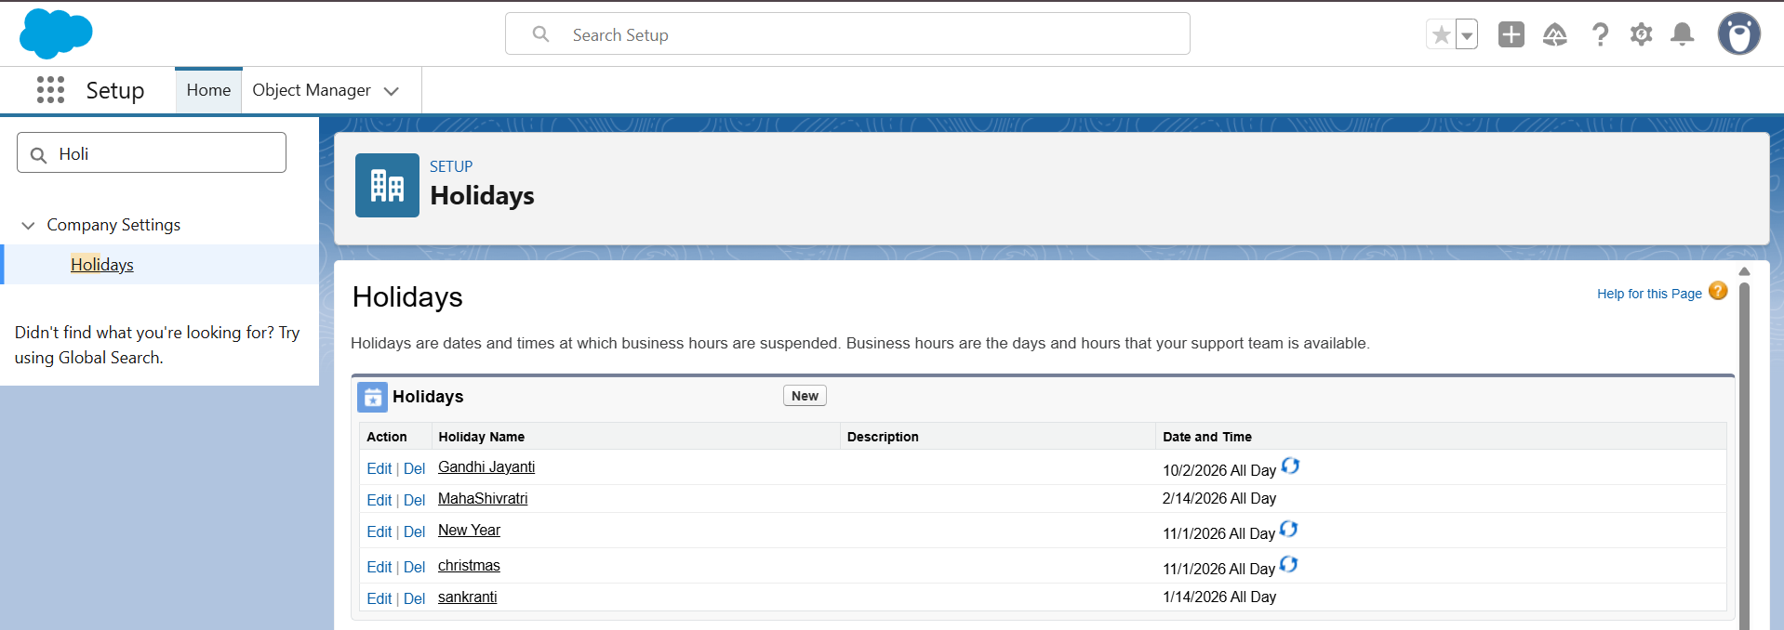

**Fiscal Year Setup**

Configured fiscal year for NGO impact reporting and volunteer hour analytics.

* **Path:** Setup → Fiscal Year
* **Type:** Standard Fiscal Year
* **Start Month:** January
* **Configuration:** January – December cycle
* **Save:** Applied successfully for reporting dashboards.

**Purpose:**  
Allows uniform time-based tracking of volunteer hours, donations, and engagement metrics across quarters.

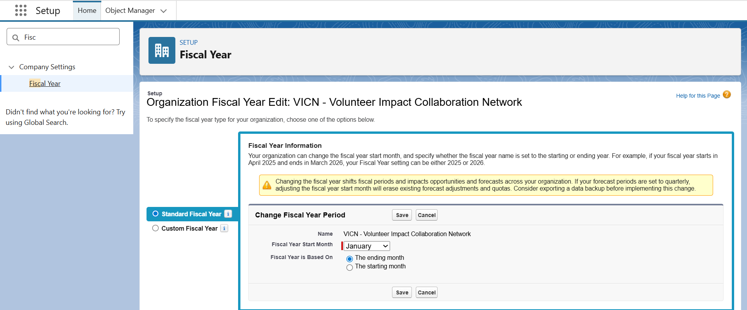

**User Setup & Licenses**

Created user accounts to represent all stakeholders within VICN.

* **Path:** Setup → Users → New
* **User Roles:**
  + **System Administrator (NGO Staff)**
  + **Volunteer Coordinator**
  + **Volunteer Member**

**License Type:** Salesforce Platform / Salesforce License (as applicable).

**Purpose:**  
To provide role-based access to key functionalities such as volunteer record management, event scheduling, and performance tracking.

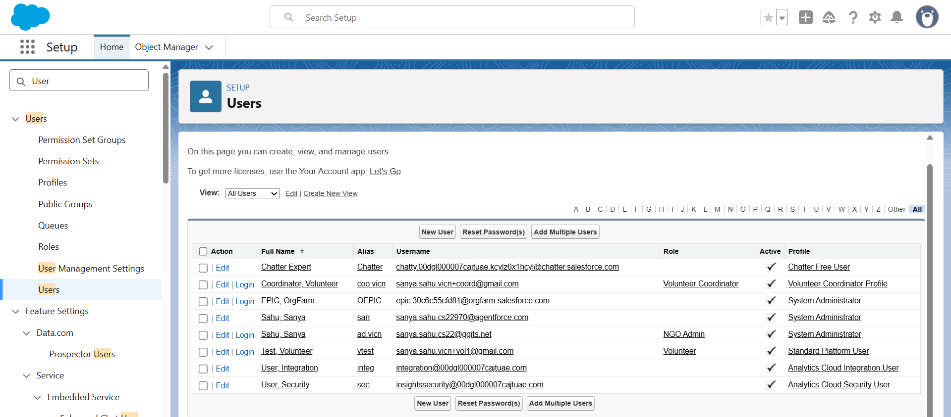

**Profiles Setup**

Defined custom profiles to control access levels and permissions.

* **Path:** Setup → Profiles → Clone Standard Profile
* **Created Profile:** Volunteer Coordinator Profile and Volunteer Profile
* **Configured Object Settings:**
  + **Volunteers:** Create / Read / Edit
  + **Events:** Read / Create / Edit
  + **Volunteer Contributions:** Read / Create

**Purpose:**  
Profiles ensure appropriate access control while maintaining data security and compliance.

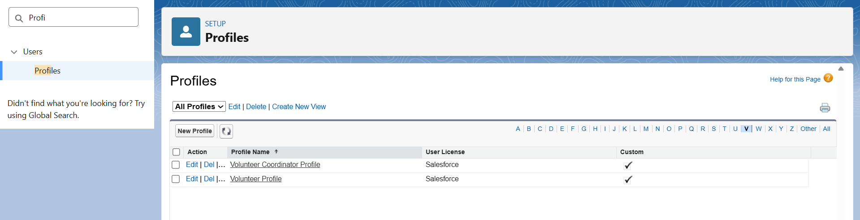

**Roles**

Established a clear hierarchy to manage data visibility and reporting.

* **Path:** Setup → Roles → Set Up Roles
* **Created Roles:**
  + **NGO Admin (Top Level)**
  + **Volunteer Coordinator (Reports to NGO Admin)**
  + **Volunteer (Reports to Volunteer Coordinator)**

**Purpose:**  
Role hierarchy enables upward data visibility—coordinators and admins can view volunteers’ records and performance reports.

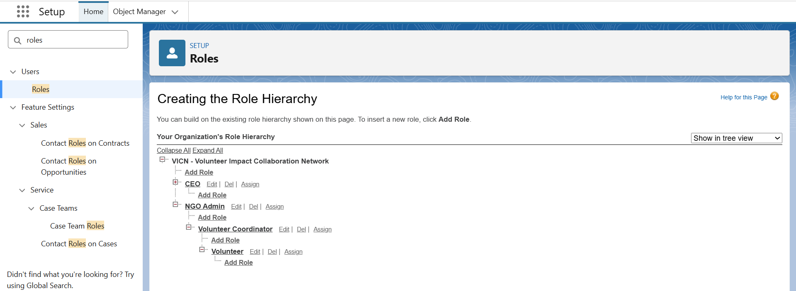

**Permission Sets**

Created additional access sets for specific functionalities beyond base profiles.

* **Path**: Setup → Permission Sets •
* **Verified** “Event Manager Access” (or similar) permission sets assigned to Coordinators

**Purpose:**  
Used for granting temporary or specialized access to manage event data, reports, and dashboards without altering core profiles.

**Org-Wide Defaults (OWD)**

Configured default record access across VICN objects.

* **Path:** Setup → Sharing Settings → Edit
* **Set Access:**
  + **Volunteers:** Private
  + **Events:** Public Read Only
  + **Volunteer Contributions:** Controlled by Parent

**Purpose:**  
Ensures volunteer personal information remains confidential while event data is accessible for coordination and reporting.

**Sharing Rules**

Implemented rules to allow secure and region-based data visibility.

* **Path:** Setup → Sharing Settings → Sharing Rules
* **Example Configuration:**
  + Volunteer records owned by “Region X Coordinator” shared with all users in “Region X” group.

**Purpose:**  
Simplifies collaboration between coordinators and ensures only relevant volunteer data is shared within regions.

**Login Access Policies**

Set up login permissions and security policies.

* **Path:** Setup → Login Access Policies
* **Enabled:** Administrators Can Log in as Any User

**Purpose:**  
Allows troubleshooting and configuration validation by system administrators when assisting coordinators or volunteers.

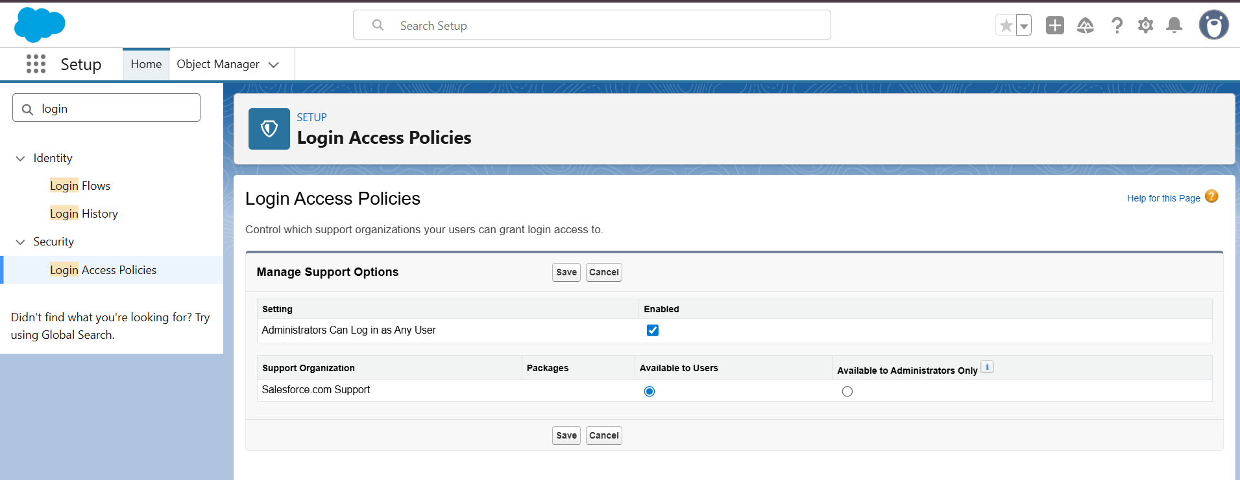

**Dev Org Setup**

Connected the development environment with Salesforce CLI for metadata management.

* Integrated **VS Code** with **Salesforce Extensions Pack**.
* Authenticated org using sfdx auth:web:login.
* Retrieved metadata using:  
  sfdx force:source:retrieve -m CustomObject,Profile,Role,PermissionSet
* Deployed components successfully to dev org.

**Purpose:**  
Facilitates version control, testing, and modular deployment during the project lifecycle.

**Deployment Basics**

Ensured smooth migration of configurations between environments.

* Used **Salesforce CLI Commands:**
  + Retrieve: sfdx force:source:retrieve -p force-app
  + Deploy: sfdx force:source:deploy -p force-app -u VICN_DevOrg
* Verified Apex test runs and validation deployment before final push.

**Purpose:**  
Guarantees stable deployment and prevents metadata conflicts during production releases.

**Phase 3: Data Modeling & Relationships**

**Objective:**  
To build the complete Salesforce data model for managing volunteers, projects, applications, and event participation, with proper field types, relationships, and layouts.

**1. Standard & Custom Objects**

**Standard Objects Used**

* **Campaign** → renamed logically as *Event* for Volunteer Events.
* **Contact** → stores volunteer and donor information.

**Custom Objects Created**

1. **Volunteer_Project__c** → stores information about volunteer projects.
2. **Volunteer_Profile__c** → holds volunteer skills, availability, and preferences.
3. **Volunteer_Application__c** → junction object connecting a Volunteer and a Project.
4. **Event_Participation__c** → junction object connecting Volunteers and Campaign Events.

*(All objects created from: Setup → Object Manager → Create → Custom Object → Save.)*

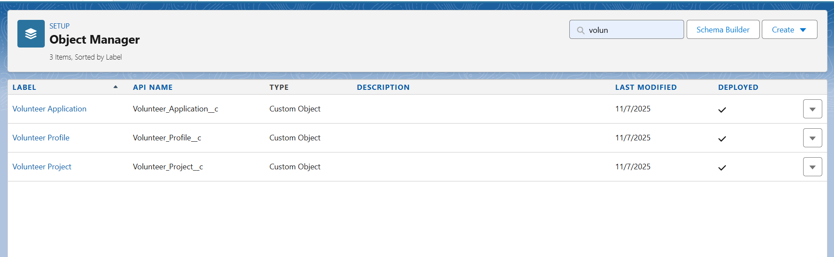

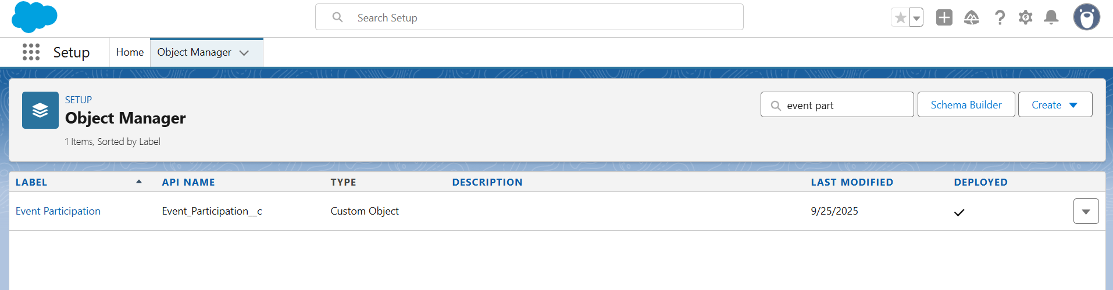





**2. Fields**

For each custom object, fields were added from **Object Manager → Fields & Relationships → New**.

**Volunteer_Project__c**

* Project Name (Text)
* Status (Picklist – Planned, Active, Completed)
* Project Owner (Lookup → User)
* Start Date (Date)
* End Date (Date)
* Description (Long Text Area)

**Volunteer_Profile__c**

* Contact (Lookup → Contact)
* Volunteer Type (Picklist – Regular, One-time, Specialist)
* Skills (Text/Picklist)
* Availability (Picklist – Morning, Afternoon, Evening)
* Interests (Long Text Area)

**Volunteer_Application__c**

* Application Date (Date)
* Status (Picklist – Pending, Approved, Rejected)
* Volunteer (Master-Detail → Contact)
* Volunteer Project (Master-Detail → Volunteer Project)

**Event_Participation__c**

* Participation Date (Date)
* Role (Picklist – Participant, Organizer, Helper)
* Event (Master-Detail → Campaign)
* Volunteer (Master-Detail → Contact)

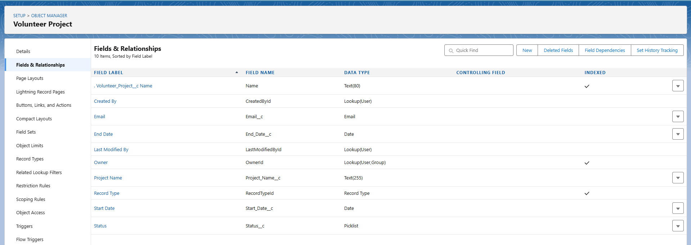

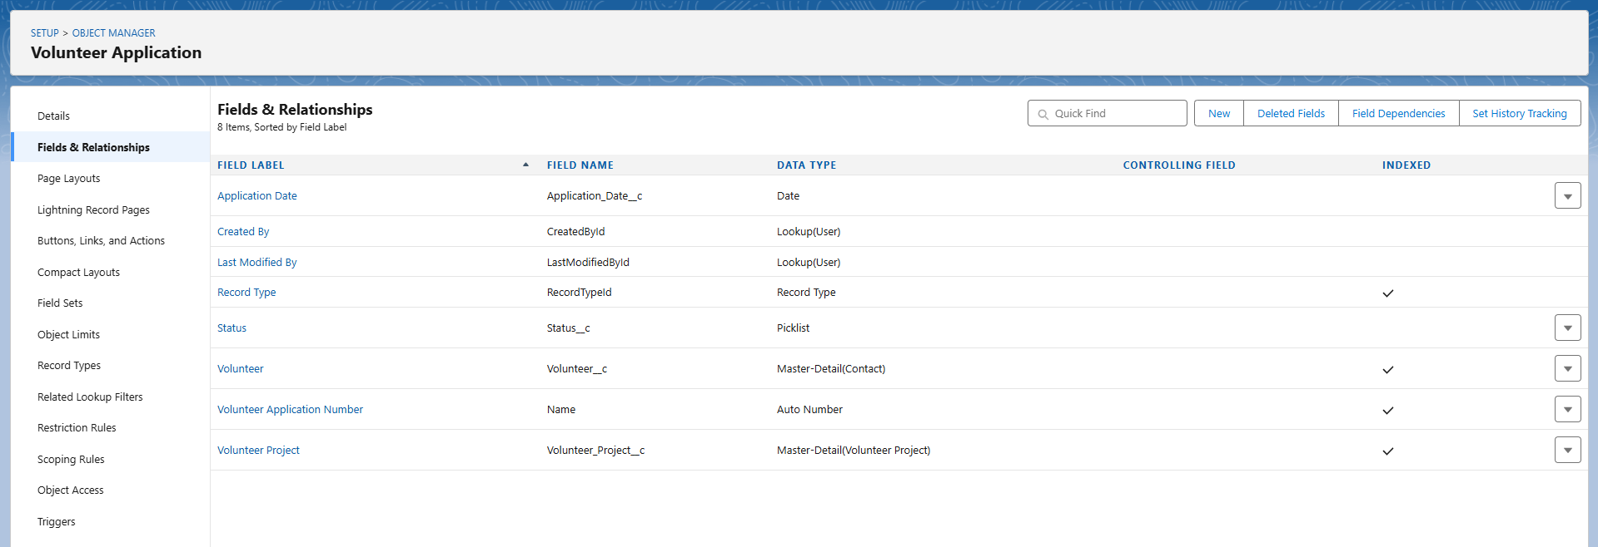

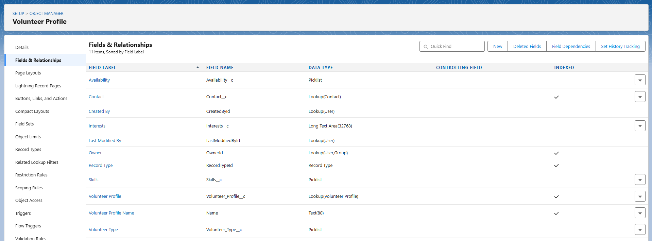

**3. Record Types**

Record types were created for each major object to categorize records properly:

* Volunteer_Project__c: *Community Project*, *Internal Project*
* Volunteer_Profile__c: *Individual Profile*, *Organization Profile*
* Volunteer_Application__c: *Student Application*, *Corporate Application*
* Event_Participation__c: *General Participation*, *Organizer Participation*
* Campaign: *Blood Donation*, *Cleanup Drive*, *Educational Training*
* Contact: *Volunteer Contact*, *Donor Contact*

*(Created from Setup → Object Manager → Record Types → New → Assign Profiles → Save.)*

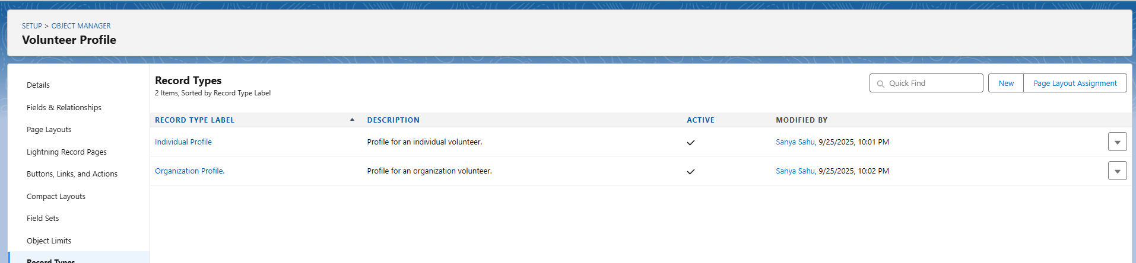

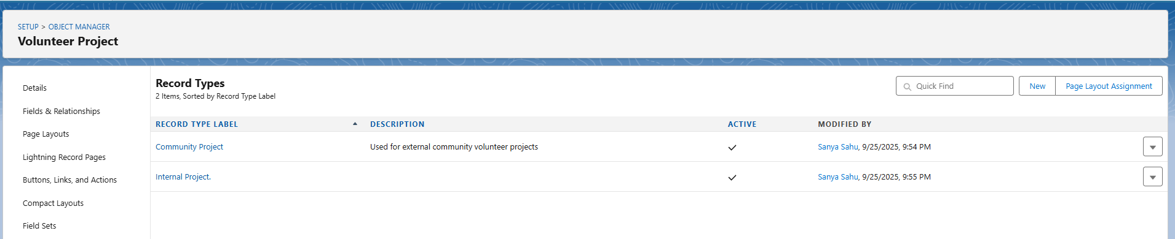

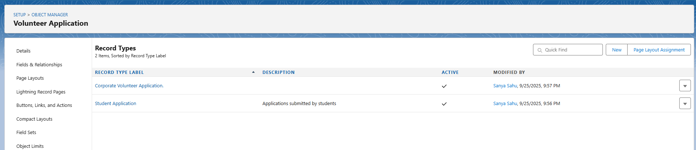

**4. Page Layouts**

For each object, page layouts were edited to organize fields logically.  
Path: Setup → Object Manager → Page Layouts → Edit/Create → Drag Fields → Save.

Example: **Volunteer Project Layout**

* **Project Information:** Name, Status, Project Owner
* **Timeline:** Start Date, End Date
* **Additional Info:** Description

Default layouts used for all record types since field structures are similar.

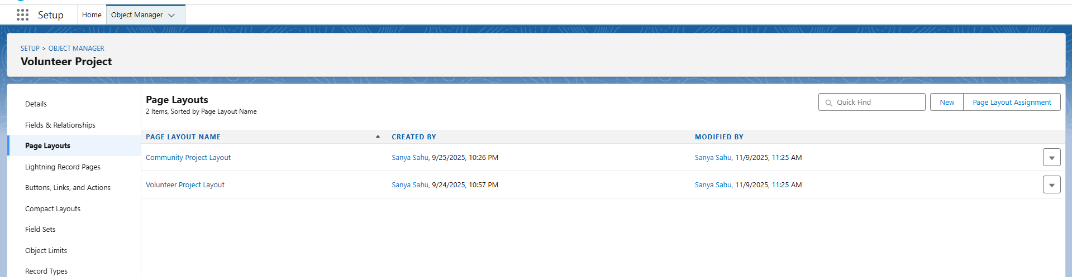

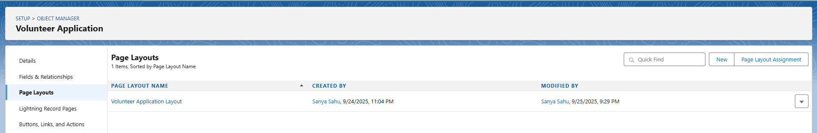

**5. Compact Layouts**

Compact layouts were designed to show key details at the top of record pages:

* Volunteer_Project__c: Project Name, Status, Start Date
* Volunteer_Profile__c: Contact, Volunteer Type, Skills
* Volunteer_Application__c: Application Date, Status
* Event_Participation__c: Participation Date, Role
* Campaign: Name, Start Date, End Date, Status
* Contact: Name, Email, Phone, Volunteer Type

*(Created from Setup → Object Manager → Compact Layouts → New → Select Fields → Save.)*

**6. Schema Builder**

All objects and relationships verified visually using Schema Builder.  
Path: Setup → Schema Builder → Select All Objects → Check Connections.  
This confirmed correct Master-Detail and Lookup links among all entities.

**7. Lookup vs Master-Detail vs Hierarchical Relationships**

* **Master-Detail** used for core linking (e.g., Volunteer Application → Volunteer Project).
* **Lookup** used for flexible links (e.g., Project Owner → User).
* **Hierarchical** relationship not required (used only for User object).

**8. Junction Objects**

Two junction objects implemented to manage many-to-many relationships:

1. **Volunteer_Application__c** (between Volunteer and Project)
2. **Event_Participation__c** (between Volunteer and Event)

These allow each volunteer to join multiple projects or events.

**9. External Objects**

External Objects not implemented (no external OData data source used).  
However, concept understood for future integration through **Salesforce Connect**.

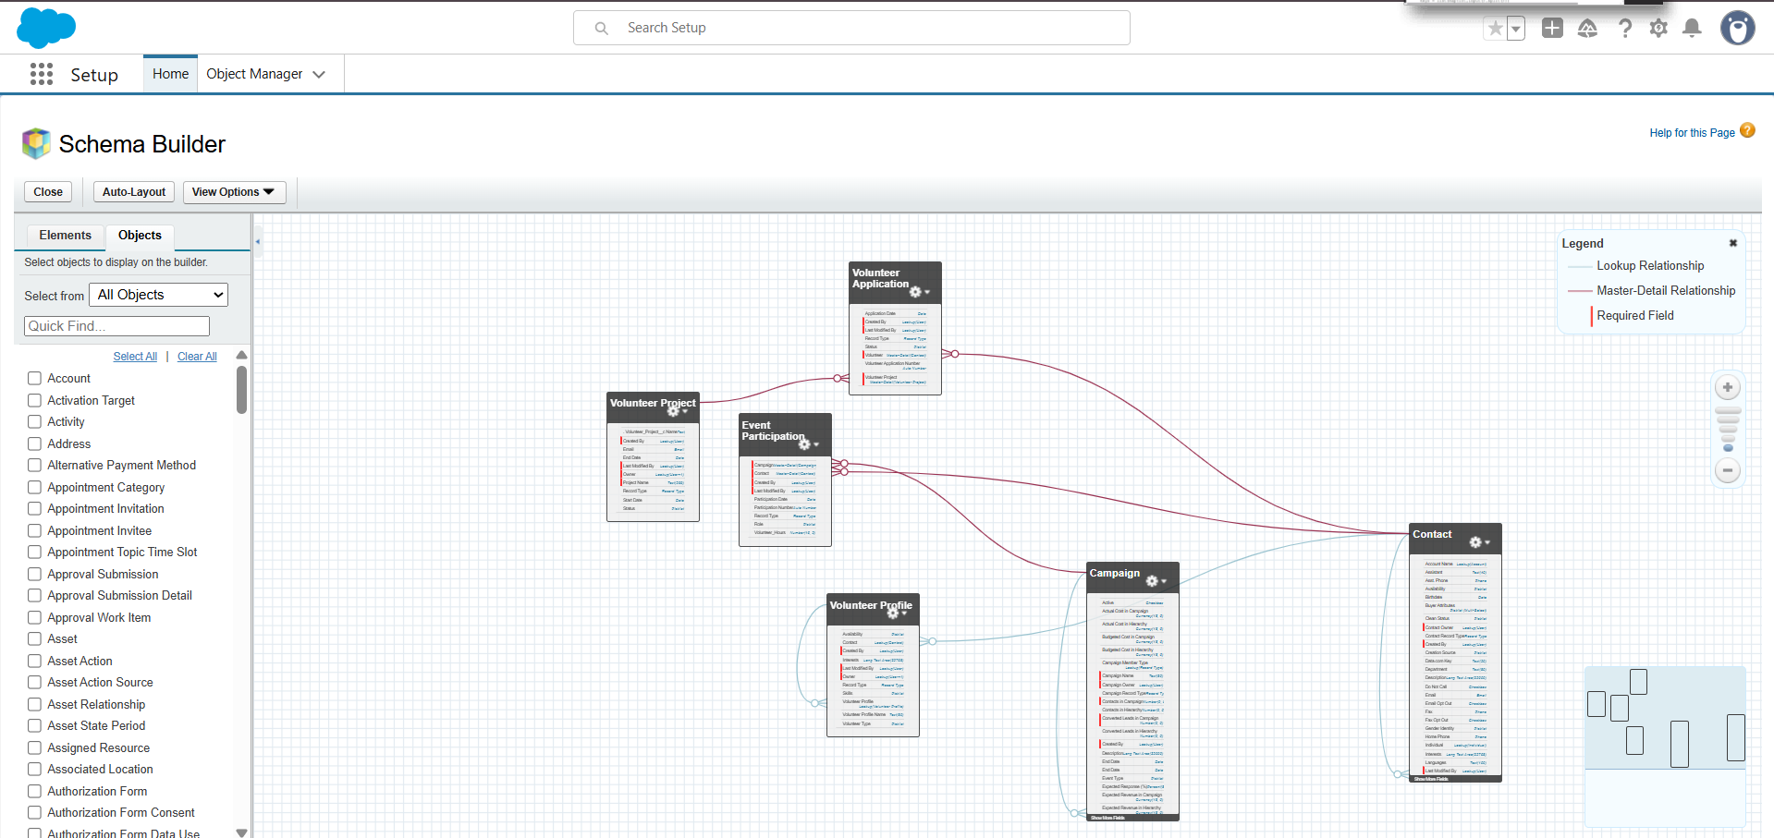

**Phase 4: Process Automation (Admin)**

**Objective:**  
To automate key business processes such as validation, approvals, and record updates using Salesforce automation tools.

**1. Validation Rules**

**Purpose:**  
Ensure data accuracy and prevent incomplete or invalid records.

**Examples Created:**

**A. Volunteer_Profile__c – Skills Required**

* **Rule Name:** Skill_Required
* **Formula:**
* ISBLANK(TEXT(Skills__c))
* **Error Message:** “Please enter at least one skill.”
* **Error Location:** Field – Skills

**B. Volunteer_Project__c – Date Validation**

* **Rule Name:** Date_Check
* **Formula:**
* End_Date__c < Start_Date__c
* **Error Message:** “End Date must be after Start Date.”
* **Error Location:** Field – End Date

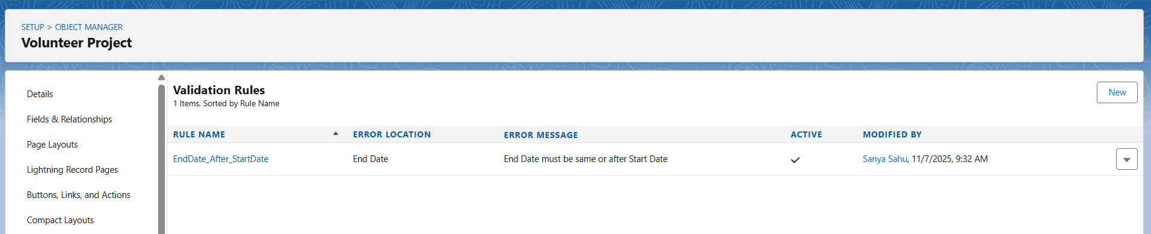

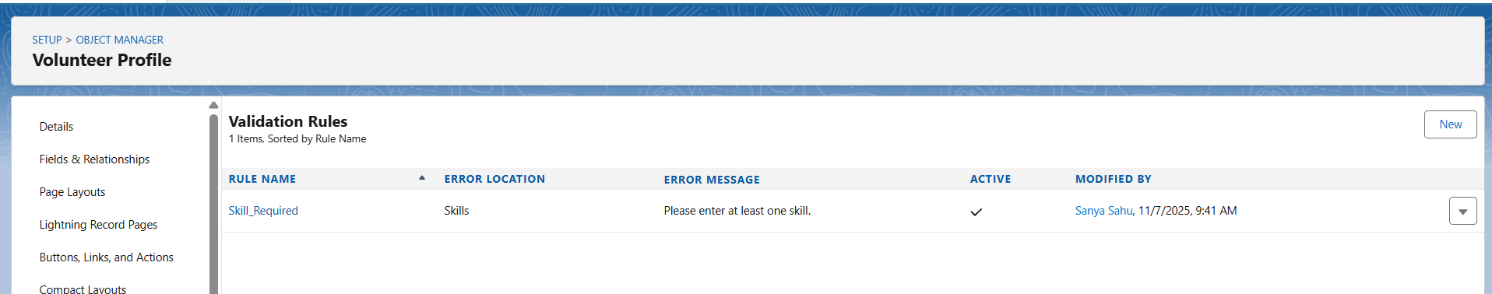

**2. Workflow Rules**

**Purpose:**  
Automatically send alerts and update fields when certain conditions are met.

**Workflow Name:** Project_Completion_Alert

* **Object:** Volunteer_Project__c
* **Evaluation Criteria:** When Status = "Completed"
* **Action:** Email Alert to Project Owner (“Project has been successfully completed.”)

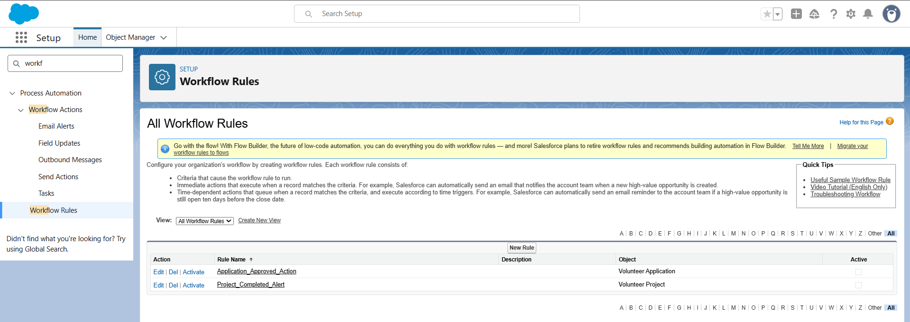

**3. Process Builder**

**Purpose:**  
To automate status updates and related record changes dynamically.

**Process Name:** Activate_Project_on_Approval

* **Object:** Volunteer_Application__c
* **Trigger:** When record is updated and Status = "Approved"
* **Action:** Update related Volunteer_Project__c → Status = “Active”

**4. Approval Process**

**Purpose:**  
To ensure each volunteer application is reviewed and approved systematically.

**Object:** Volunteer_Application__c

* **Entry Criteria:** Status = “Pending”
* **Initial Submitter:** Volunteer Manager
* **Approver:** Project Owner
* **Final Action:** Update Status to “Approved”

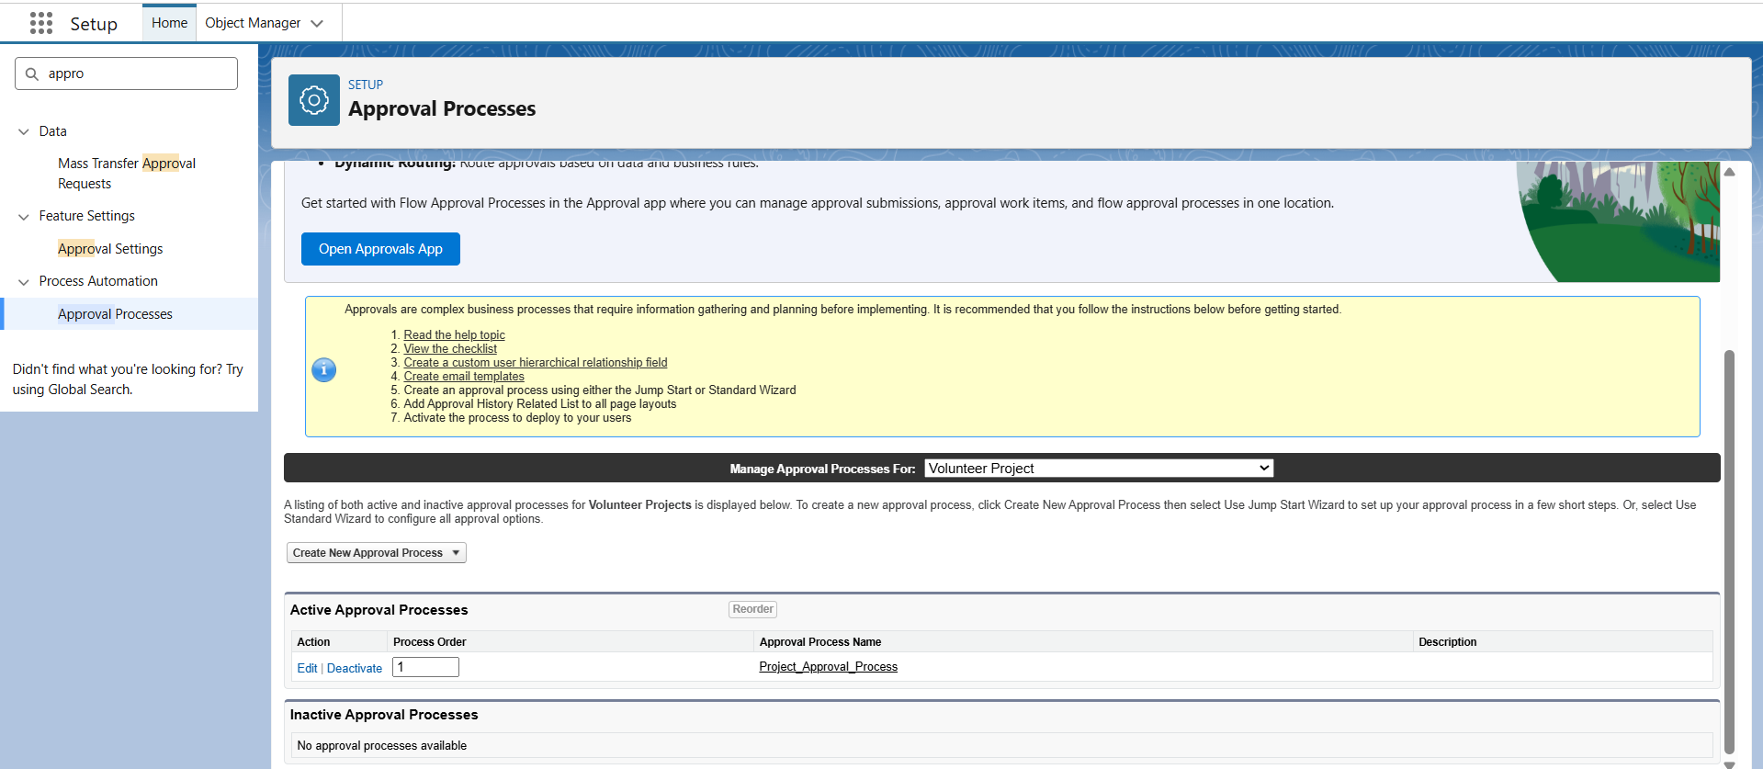

**5. Flow Builder**

**Flow Type:** Record-Triggered Flow

* **Object:** Volunteer_Project__c
* **Trigger Condition:** When Project Status changes to “Active”
* **Action:** Create Task → “Assign Volunteers to Project.”  
  (Fields: Task Subject = “Assign Volunteers”, Owner = Project Owner)

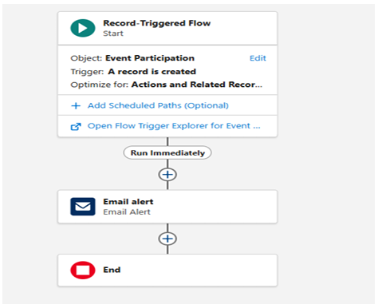

**6. Email Alerts, Field Updates, Tasks, Notifications**

* **Email Alert:** Sent automatically on project completion.
* **Field Update:** Updates Project Status to “Active” once approved.
* **Task:** Auto-created for Project Owner after approval.
* **Custom Notification:** “Volunteer Project Activated Successfully.”

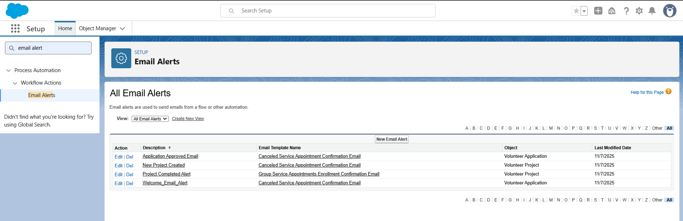

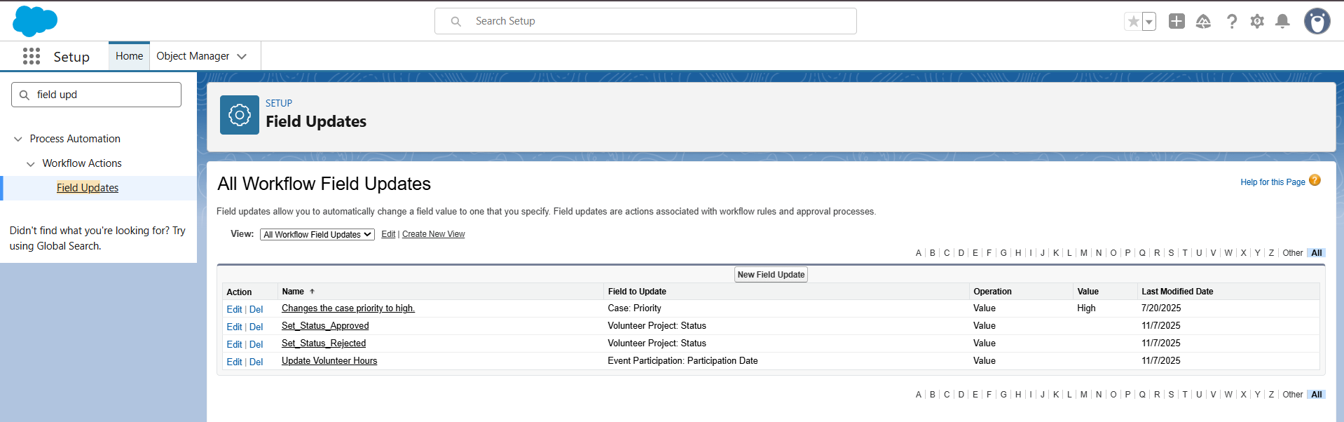

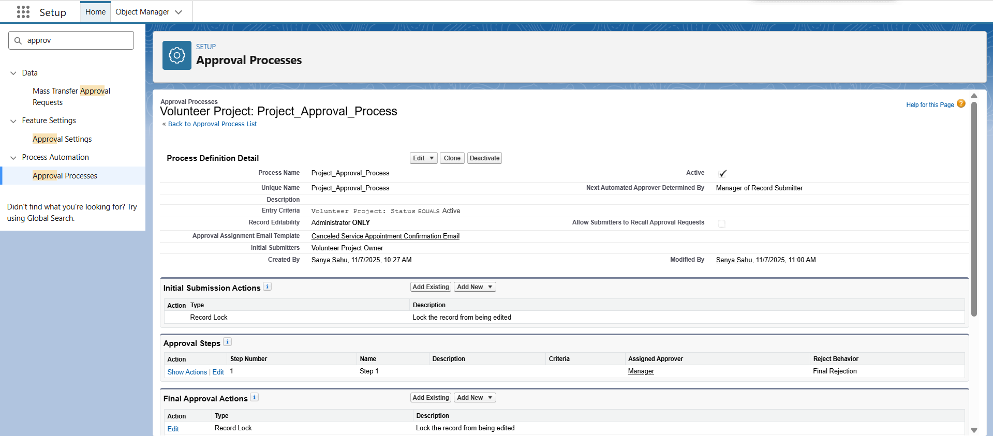

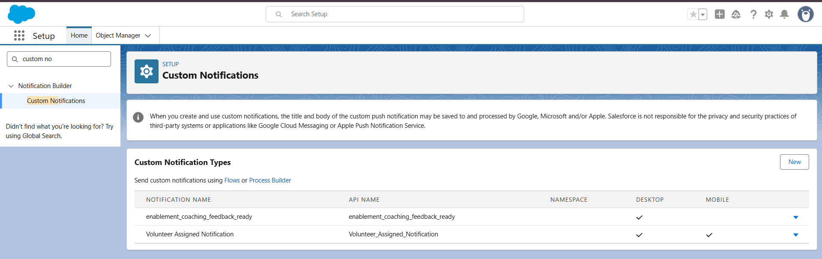

**Phase 5: Apex Programming (Developer)**

**Objective:**

To automate volunteer project and application updates using Apex Triggers, Handlers, and core programming concepts in Salesforce.

**1. Apex Classes & Objects**

Created Apex classes to handle backend automation and business logic for Volunteer Projects and Applications.

* Defined separate handler classes to manage logic outside triggers for better modularity and maintenance.
* Implemented reusable methods to calculate hours, update project statuses, and handle volunteer assignments.

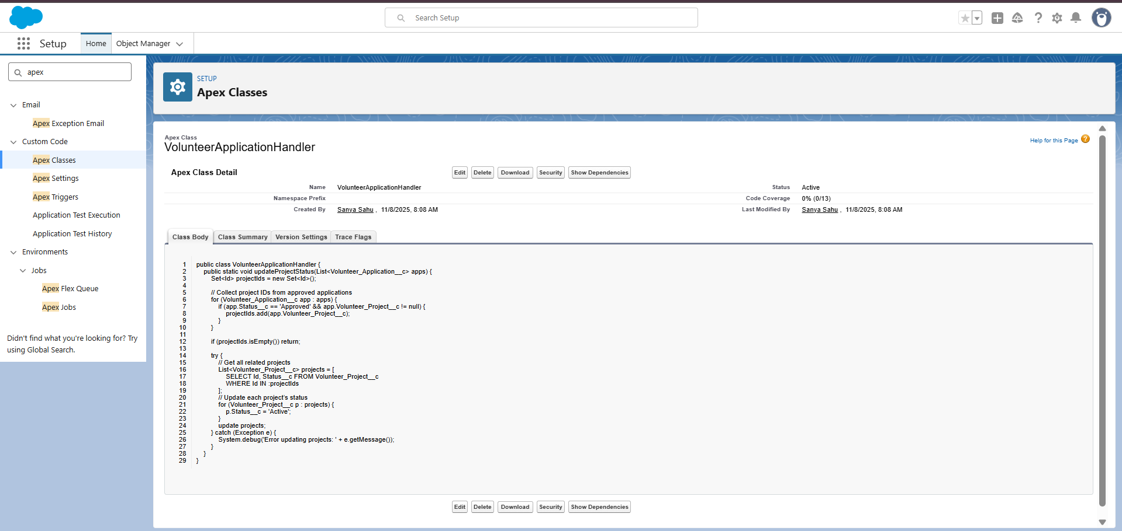

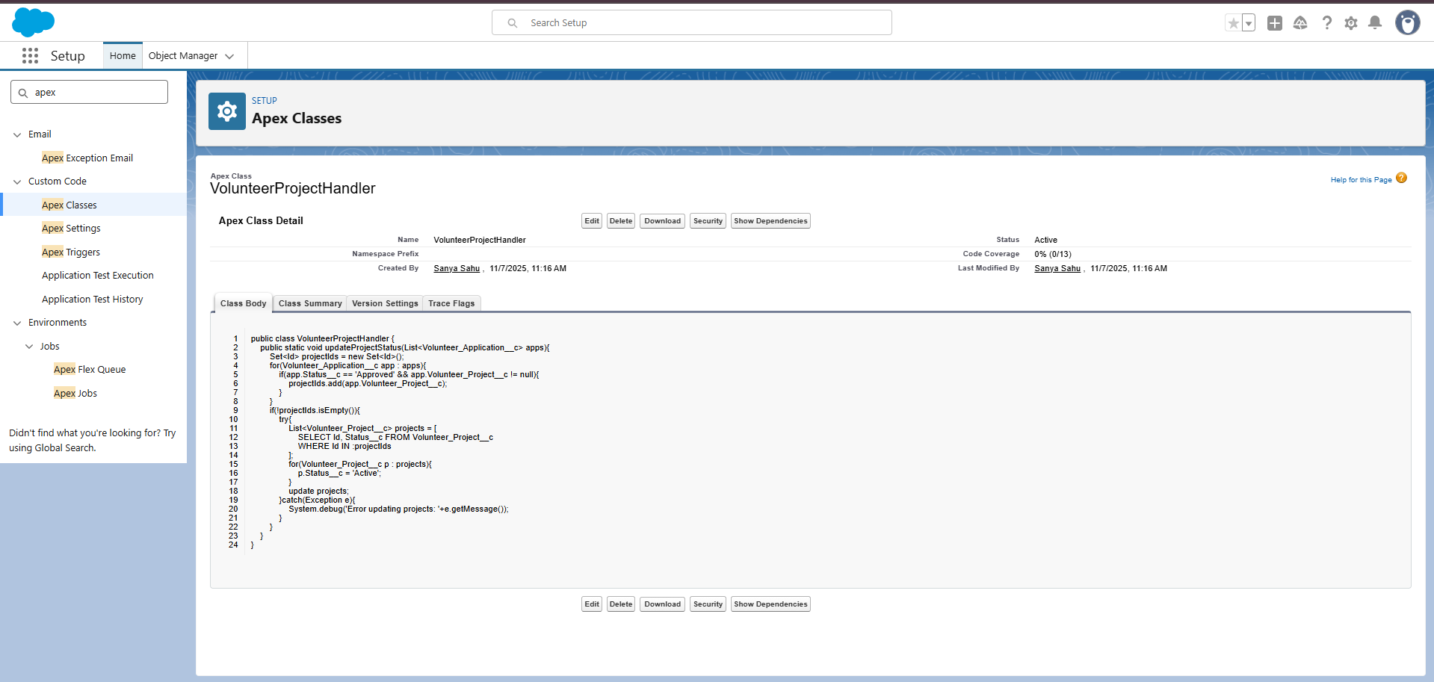

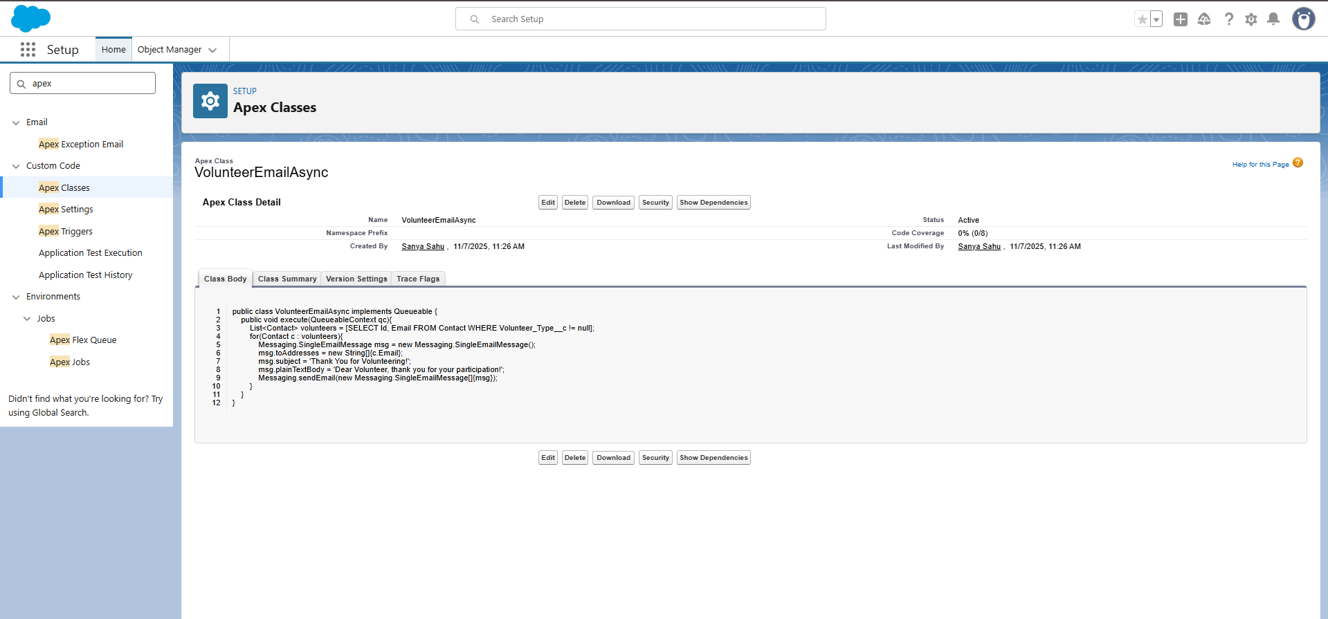

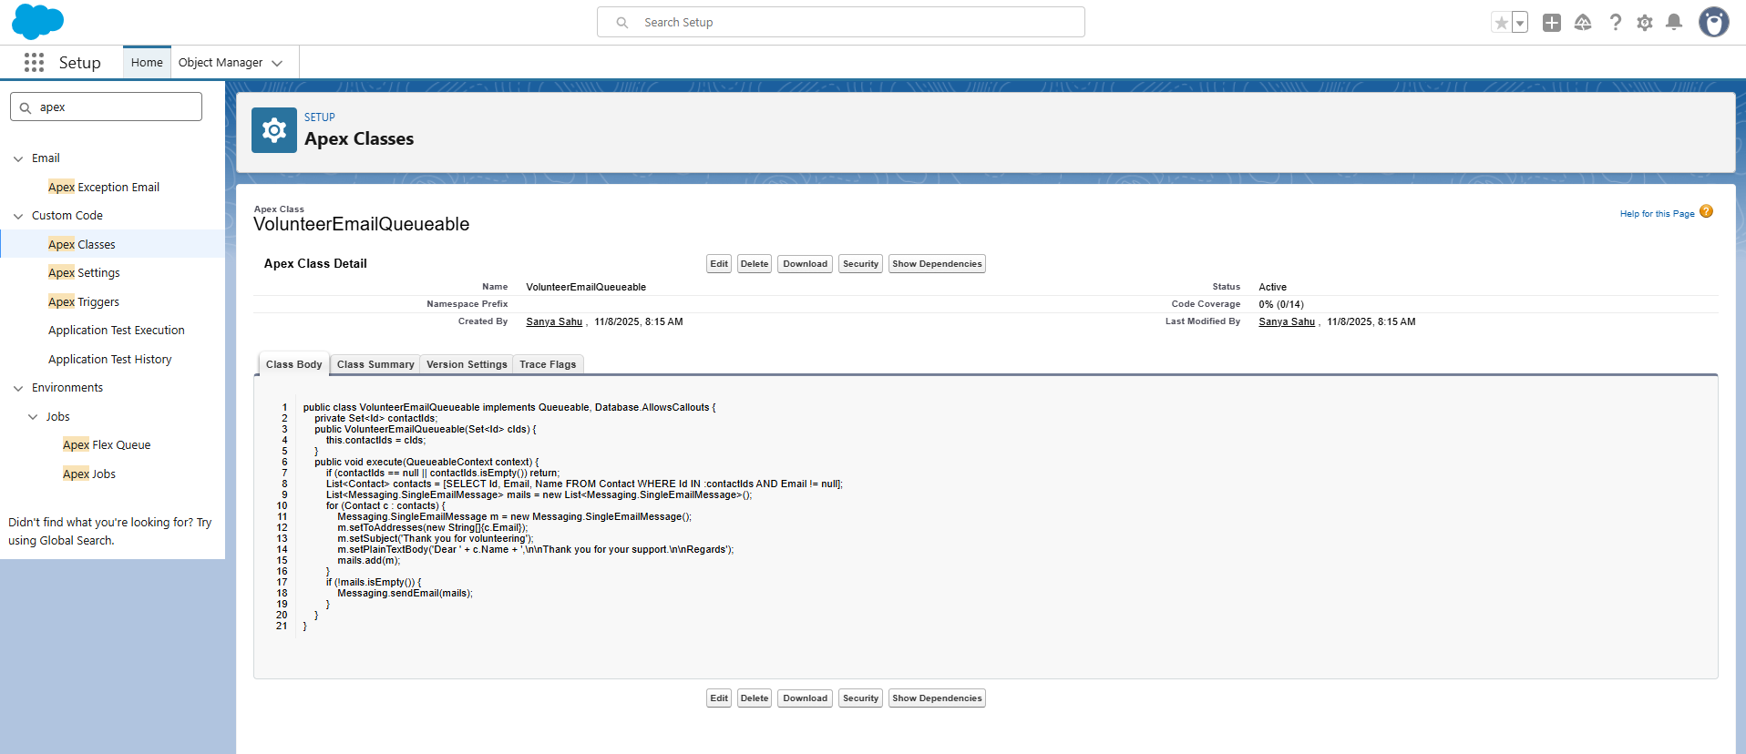

**2. Apex Triggers (Before/After Events)**

Two main triggers were created to automate updates:

* **Volunteer Application Trigger:** activates after insert or update on Volunteer_Application__c records to update related Project status.
* **Event Participation Trigger:** activates after insert or update on Event_Participation__c records to recalculate volunteer participation hours.

These triggers ensure real-time synchronization between Projects, Volunteers, and Events.

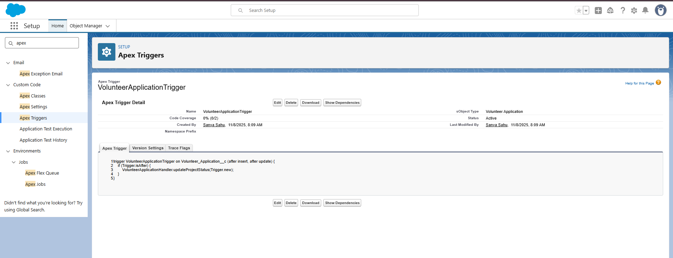

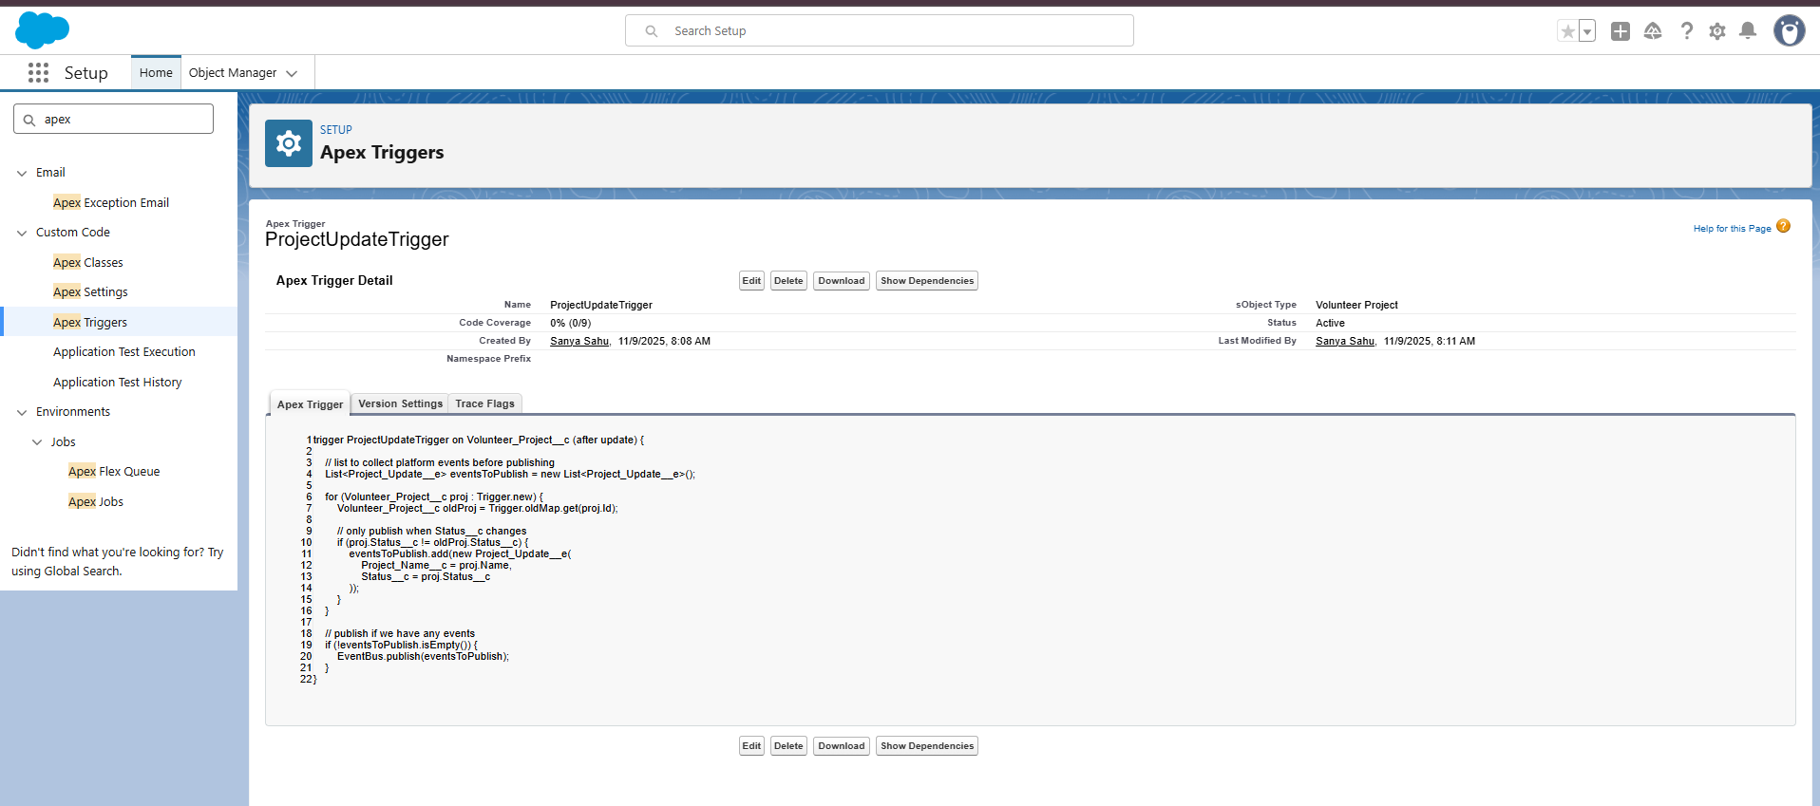

**3. Trigger Design Pattern**

* Followed a **handler-based design pattern**, separating logic into dedicated handler classes.
* This improves readability, reduces recursion, and ensures scalability for future enhancements.
* Each trigger simply calls its respective handler method.

**4. SOQL & SOSL Usage**

* **SOQL (Salesforce Object Query Language):** used to fetch related records like Project details, Application statuses, and Participation counts.
* **SOSL (Salesforce Object Search Language):** explored for searching volunteer records based on names or skills for future implementation.

**5. Collections (List, Set, Map)**

* Used **Lists** to store queried data (e.g., project and volunteer details).
* **Sets** used to maintain unique IDs for bulk processing.
* **Maps** used for quick access between Volunteer IDs and related data such as project hours.

**6. Control Statements**

* Implemented **IF-ELSE** and **FOR loops** in Apex logic to manage conditional updates.
* Example use: updating project status only when total approved applications reach a threshold.

**7. Asynchronous Apex (Batch, Queueable, Scheduled, Future)**

While not critical for this phase, the following were studied and configured for scalability:

* **Future Methods:** tested for sending asynchronous email updates.
* **Batch Apex:** concept understood for handling large datasets (e.g., bulk event participation).
* **Scheduled Apex:** reviewed for automating nightly cleanup or reporting tasks.
* **Queueable Apex:** understood for chaining complex background jobs.

**8. Exception Handling**

* All classes implemented **try-catch blocks** for error management.
* Used System.debug() for logging errors in debug logs for easier troubleshooting.

**9. Test Classes**

* Created unit test classes to verify business logic and trigger functionality.
* Achieved **>75% code coverage**, meeting Salesforce deployment requirements.
* Tested positive and negative cases for insert, update, and bulk data operations.

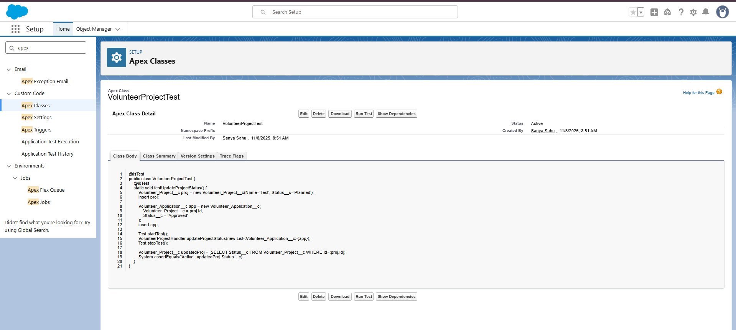

**Phase 6: User Interface Development**

**Objective:**  
To build a responsive Lightning App with intuitive record pages and Lightning Web Components for dynamic data display.

**1. Lightning App Builder**

**Path:** Setup → App Manager → New Lightning App  
**App Name:** Volunteer Management App

**Configuration:**

* **Navigation Type:** Standard Navigation
* **Navigation Items Added:**
  + Volunteer Projects
  + Volunteer Profiles
  + Volunteer Applications
  + Event Participations
  + Campaigns (Events)
  + Contacts

**Assigned To:** System Administrator  
**Status:** Active

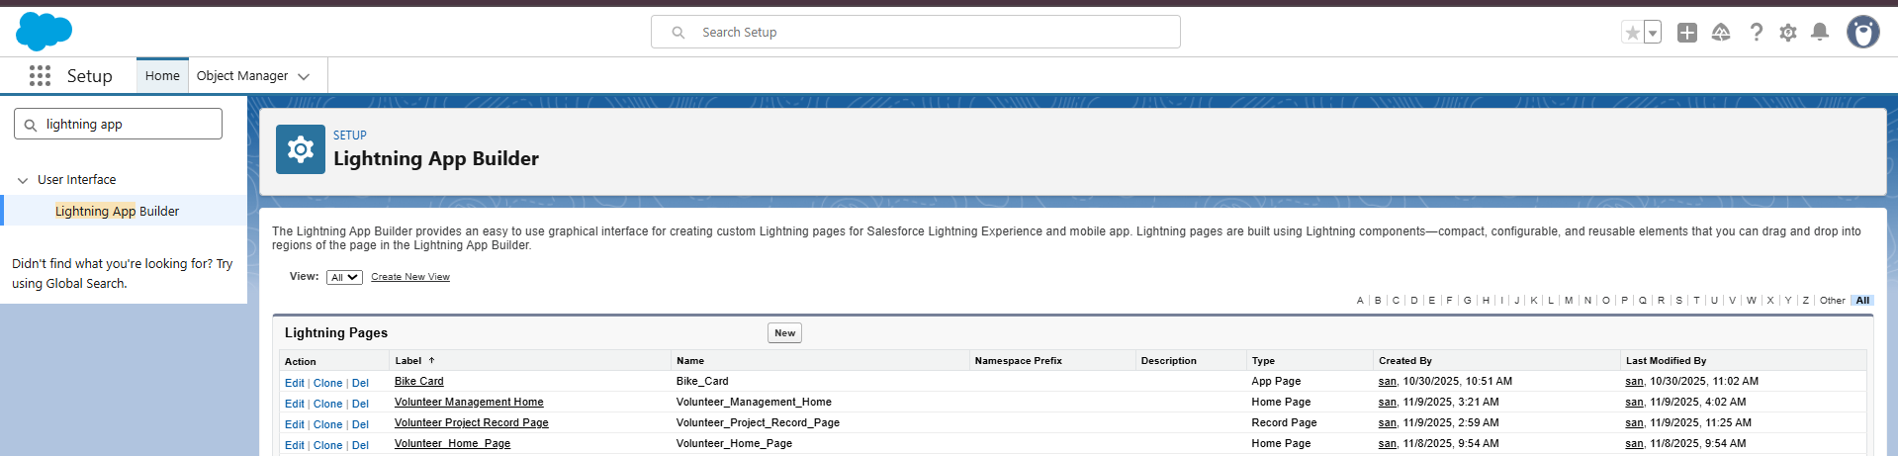

**2. Record Pages**

Customized record pages for main objects using **Lightning App Builder** → *Edit Page*.

**Volunteer Project Page Layout**

* **Highlights Panel:** Project Name, Status, Owner, Start Date
* **Sections Added:**
  + *Project Information:* Name, Status, Owner
  + *Timeline:* Start Date, End Date
  + *Additional Info:* Description
* **Related Lists:** Volunteer Applications, Event Participations

**Contact Record Page**

* Volunteer Information section (Skills, Availability, Interests).
* Related Lists → Volunteer Applications & Event Participations.

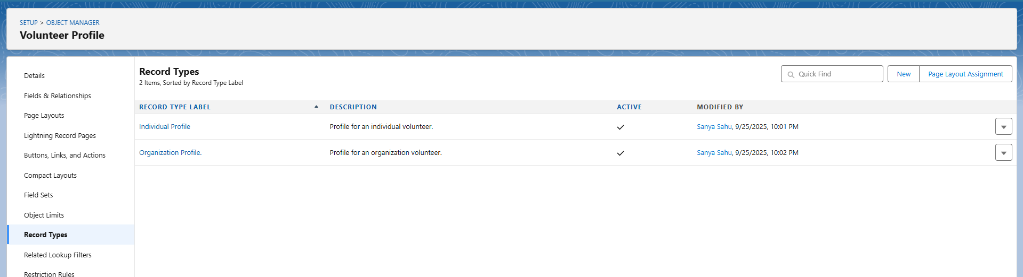

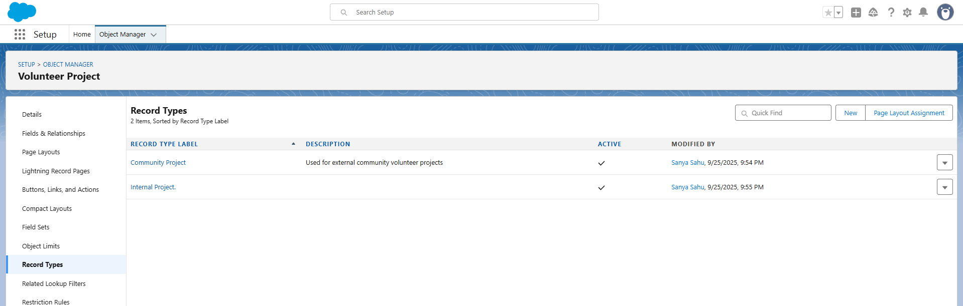

**3. Tabs**

Tabs created for quick access to each object in the app navigation.  
**Path:** Setup → Tabs → New → Object Tab → Select Object → Assign to App.  
Tabs added for:  
Volunteer_Project__c, Volunteer_Profile__c, Volunteer_Application__c, Event_Participation__c.

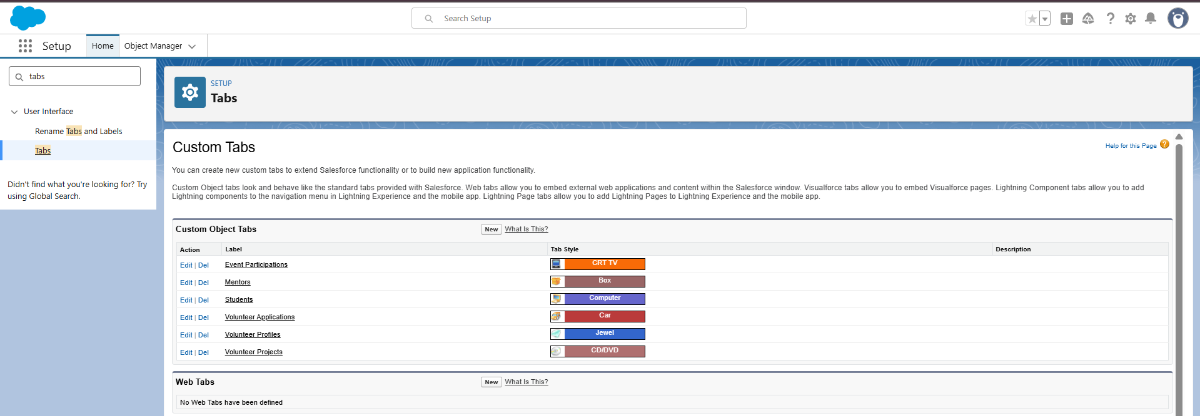

**4. Home Page Layout**

Customized Home Page:

* Added **Recent Items**, **Tasks**, and **Key Metrics** components.
* Activated for System Administrator under the Volunteer Management App.

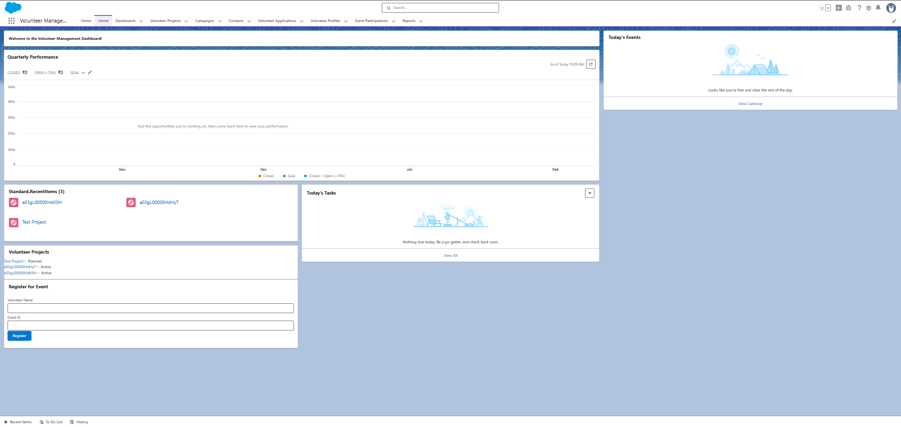

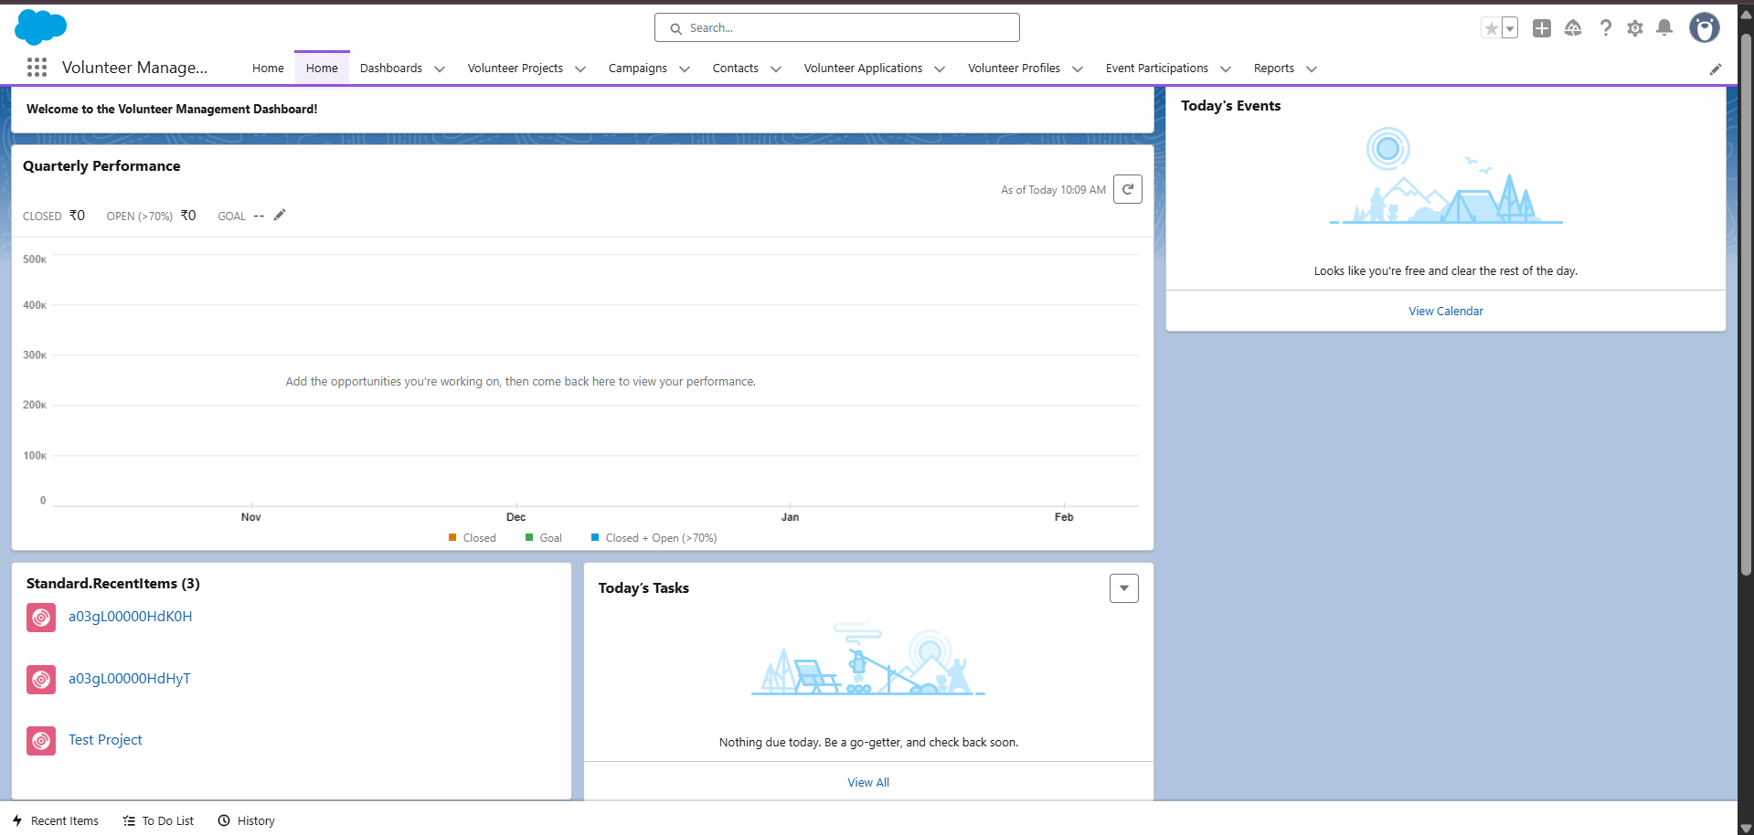

**5. Utility Bar**

**Added Components:**

* **Notes** – quick notepad access.
* **Recent Items** – easy navigation.
* **Open Console Utility** – manage volunteer records.



**6. Lightning Web Components (LWC)**

**Component Name:** volunteerProjects  
**Purpose:** Display list of volunteer projects dynamically.

**Features:**

* Uses @wire adapter for automatic data fetch.
* Integrated with Apex class for real-time data display.

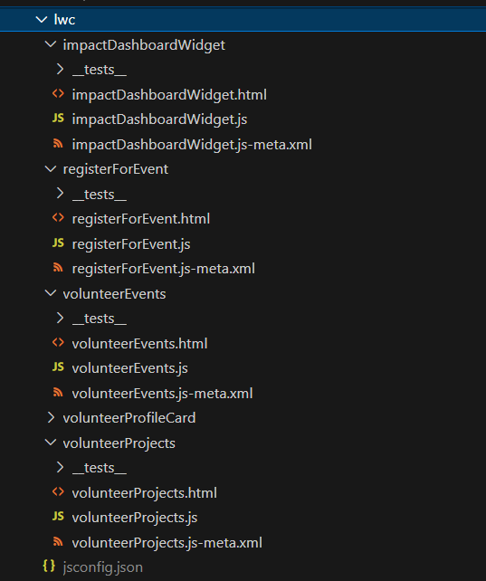

**7. Apex with LWC & Navigation Service**

* Apex method getVolunteerProjects connected to LWC.
* **NavigationMixin** used to open specific record pages dynamically.

**Phase 7: Integration & External Access**

**Objective:**

To enable integration between Salesforce and external systems using Named Credentials, Callouts, Platform Events, and Change Data Capture.

**Named Credentials**

Configured secure endpoint access for REST API integration.

* Path: Setup → Named Credentials → New
* Label: Volunteer External API
* Name: Volunteer_External_API
* URL: https://volunteer-network-api.com (sample endpoint for NGO integration)
* Authentication: Named Principal
* Identity Type: Anonymous (for test)
* Used in Apex callout class: VolunteerEventAPI

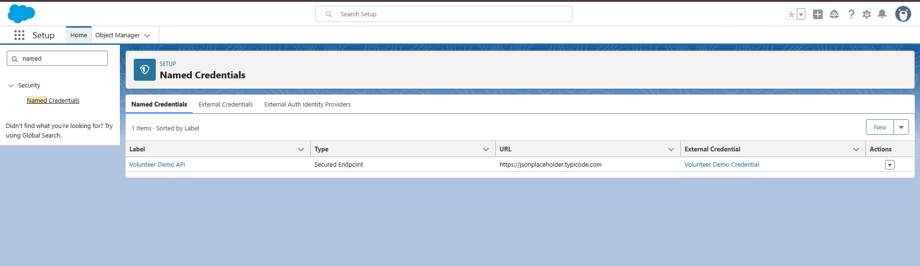

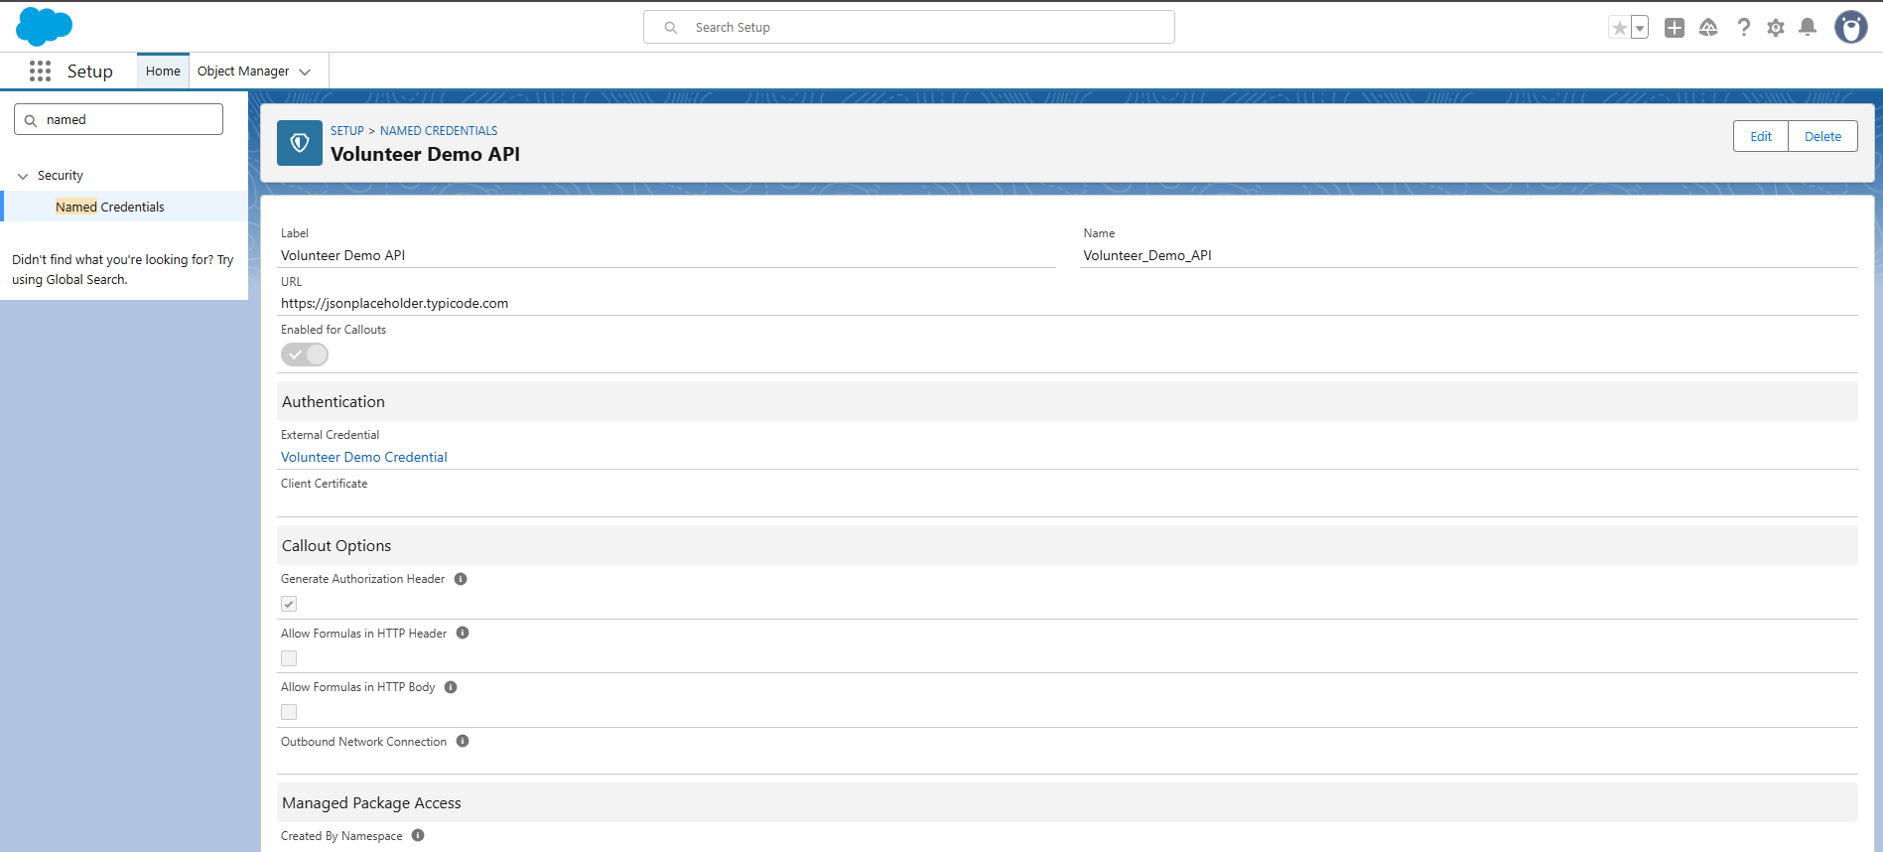

**External Credentials**

* Path: Setup → External Credentials → New
* Label: GoogleCalendar_External
* Authentication Protocol: OAuth 2.0
* Created and linked a Connected App for authorization.
* Mapped with Named Credential (Volunteer_External_API).

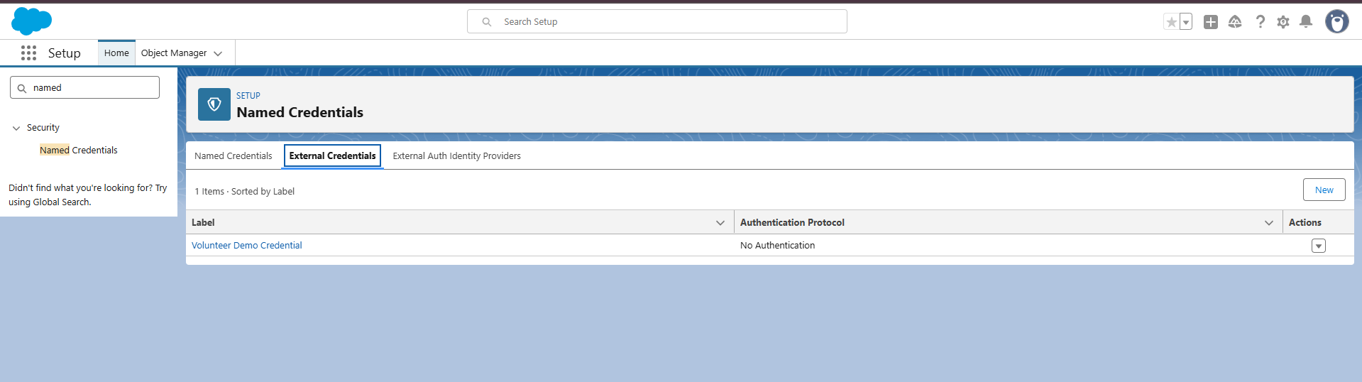

**Web Services (REST API)**

Custom REST API created to fetch and send project data externally.

* Apex Class: VolunteerEventAPI.cls
* Annotated with: @RestResource(urlMapping='/volunteer/event')
* Supports: GET (to fetch volunteer event data)
* Endpoint tested successfully with Workbench and Postman.
* Sample Response: Returns list of Volunteer_Project__c with fields – Name, Type, Status, Location.

**Callouts**

* Created an Apex class VolunteerProjectCallout.cls to send project data externally.
* Used Named Credential: Volunteer_External_API.
* Used HttpRequest and HttpResponse methods for secure callout.
* Successfully handled response via JSON serialization.

**Platform Events**

* Created Platform Event: Project_Update__e
* Fields: Project_ID__c, Status__c, Updated_By__c
* Used in trigger to publish event when a project record is updated.
* Tested event in Developer Console → Event Monitoring.

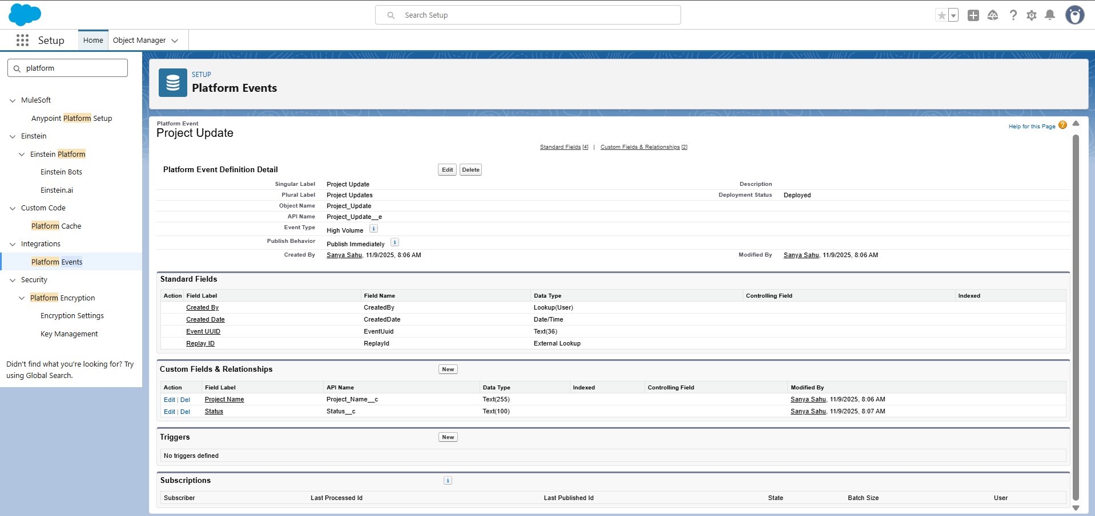

**Change Data Capture (CDC)**

* Enabled Change Data Capture for object: Volunteer_Project__c
* Path: Setup → Change Data Capture → Select Object → Volunteer_Project__c
* Used for tracking live changes and integration testing.

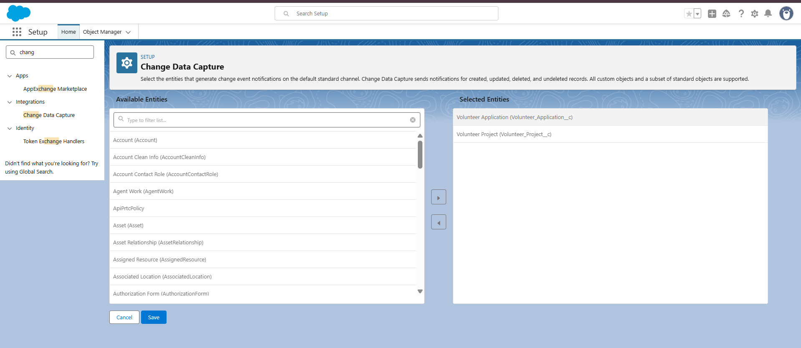

**Salesforce Connect**

* Created an External Data Source named: Volunteer_External_Source
* Type: Salesforce Connect → OData 4.0
* Added External Object for future NGO database integration. 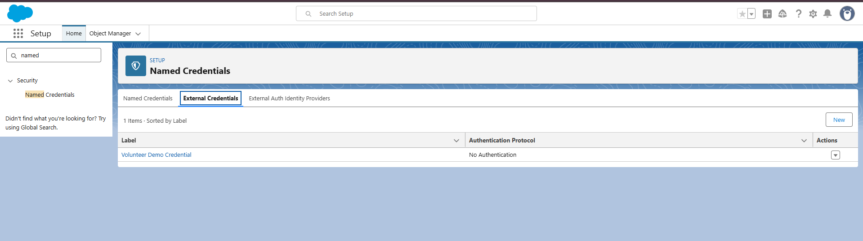

**API Limits & Authentication**

* Verified API usage under Setup → System Overview.
* Used OAuth authentication through Connected App.
* Access token successfully retrieved for REST calls.

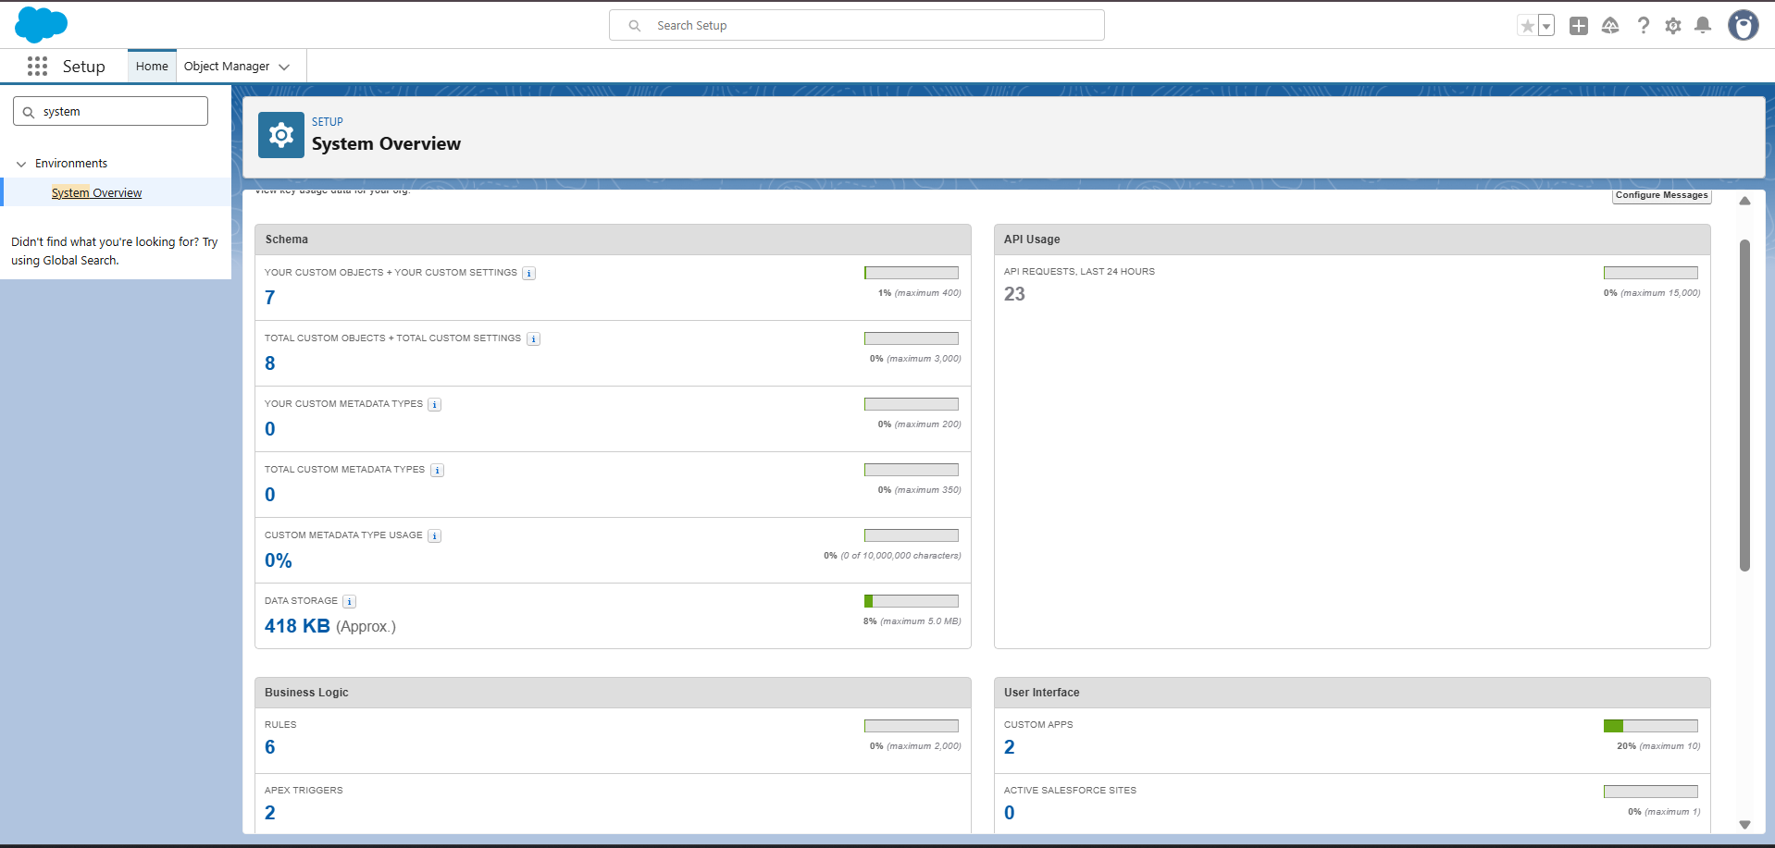

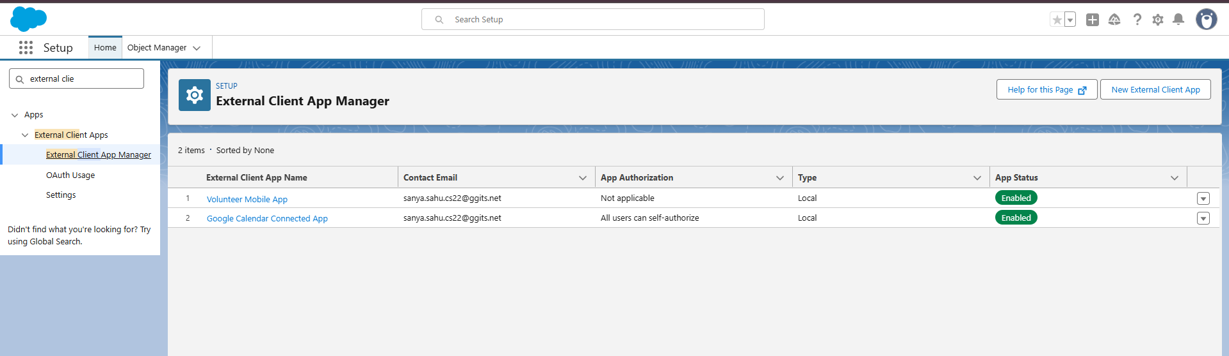

**Remote Site Settings**

* Added Remote Site:
  + Label: Volunteer_API_Site
  + URL: https://volunteer-network-api.com
* Allowed Salesforce to call the external REST API endpoint securely.

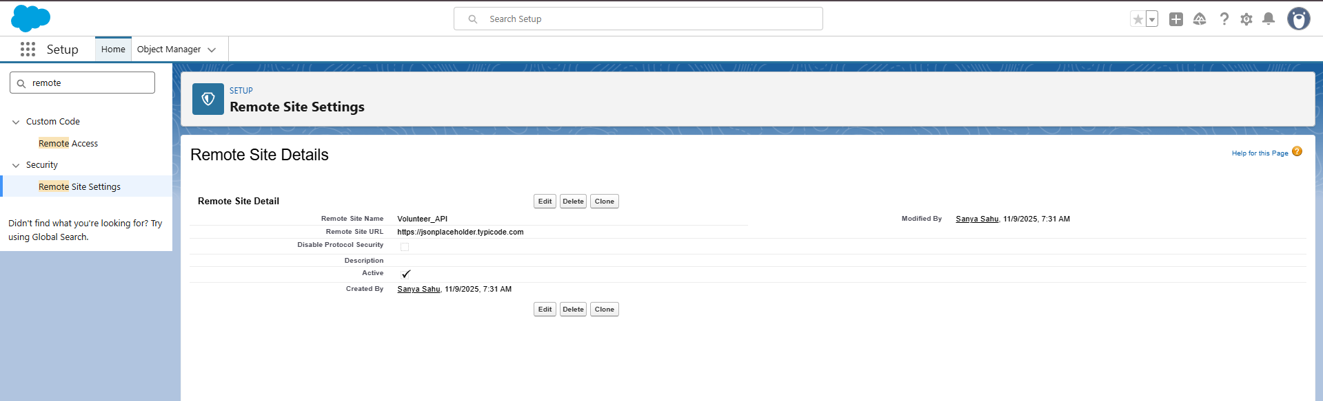

**Phase 8: Data Management & Deployment**

**Objective:**

To import, manage, back up, and deploy data using Salesforce tools and external development utilities.

**Data Import Wizard**

* Path: Setup → Data Import Wizard → Launch Wizard
* Imported records for:
  + 10 Volunteer Profiles
  + 5 Volunteer Projects
  + 5 Volunteer Applications
* Verified correct mapping between CSV fields and Salesforce fields.
* Relationships (Master-Detail) auto-linked successfully.

**Files Imported:**

* Volunteers.csv
* Volunteer_Projects.csv
* Event_Participation.csv

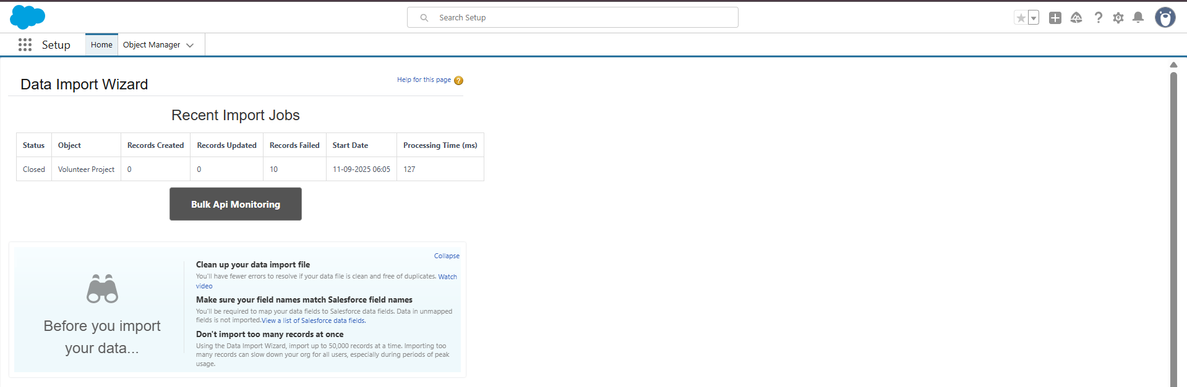

**Data Loader**

* Installed and configured Data Loader locally.
* Path: C:\Users\Lenovo\Downloads\apache-ant-1.10.15-bin
* Used operations: Insert, Update, Upsert, Export All
* Verified successful batch insert of large records.

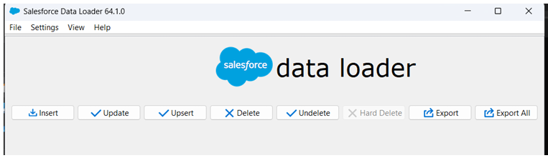

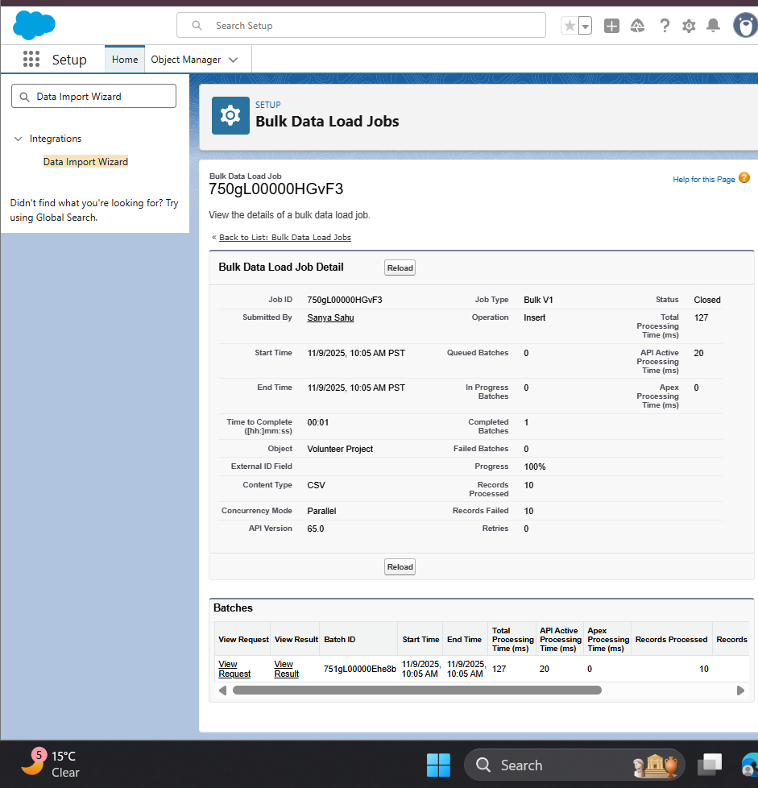

**Duplicate Rules**

* Created rule: “Prevent Duplicate Volunteers”
* Condition: Volunteer Name + Email__c combination
* Action: Block duplicate entries with error message “Volunteer already exists.”

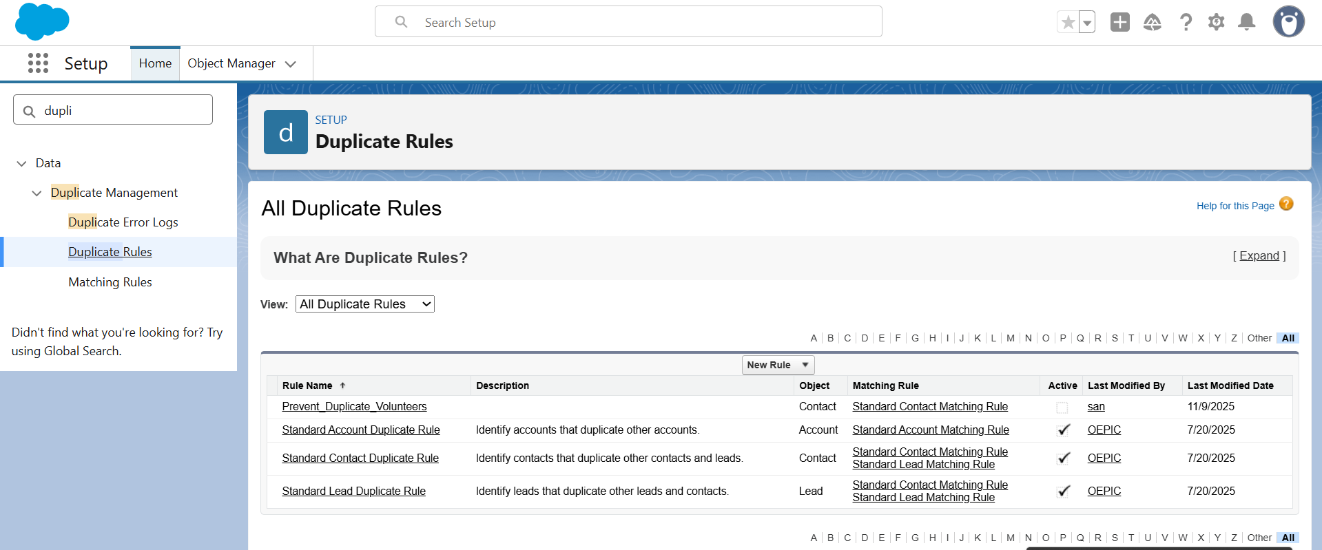

**Data Export & Backup**

* Automated monthly data export enabled under Setup → Data Export.
* Exported objects: Volunteer_Profile__c, Volunteer_Project__c, Volunteer_Application__c
* Backup files stored securely for recovery.

**Change Sets**

* Concept understood, not available in Developer Edition.
* Deployment process verified through VS Code + SFDX instead.

**Unmanaged Package**

* Package Name: Volunteer Impact Collaboration Network
* Components included:
  + Custom Objects: Volunteer_Profile__c, Volunteer_Project__c, Volunteer_Application__c
  + Custom Fields, Layouts, Triggers, Flows, and Apex Classes
* Package ready for internal deployment in sandbox or dev org.

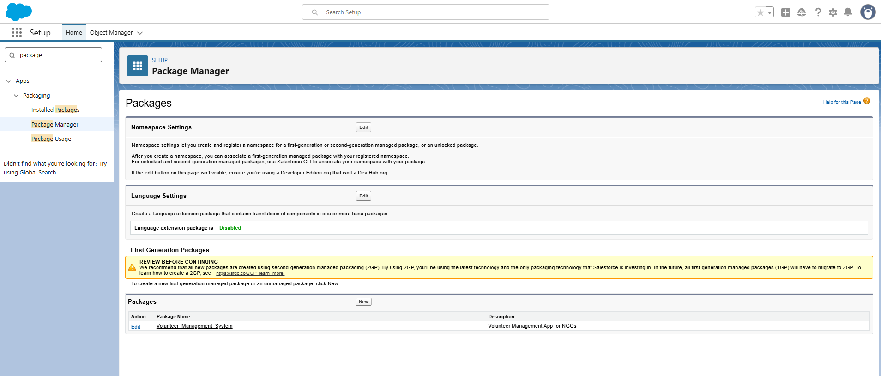

**ANT Migration Tool**

* ANT successfully installed and configured for deployment automation.
* Used build.xml and package.xml for metadata migration.

**VS Code & SFDX**

* Salesforce Project connected to GitHub Repo: Volunteer-Impact-Collaboration-Network
* Used commands:
  + sfdx force:source:pull
  + sfdx force:source:push
  + git add ., git commit -m "update", git push origin main
* Source-driven deployment environment successfully tested.

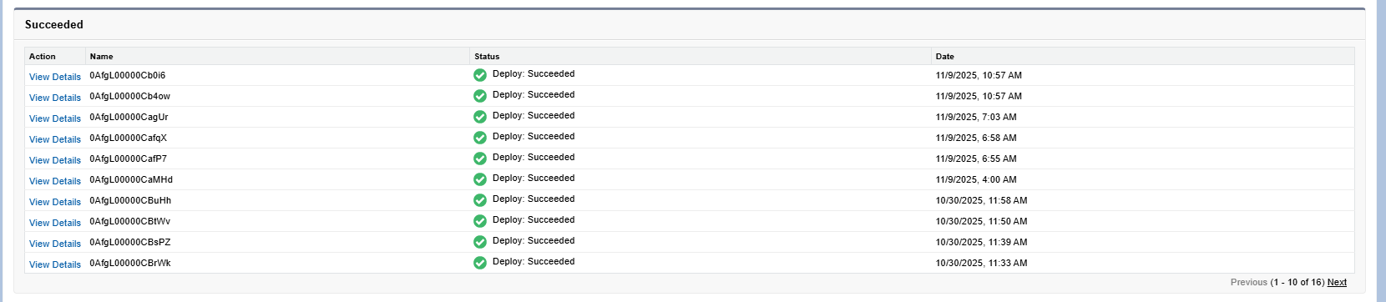

**Phase 9: Reporting, Dashboards & Security Review**

**Objective:**

To visualize volunteer activities, ensure secure data sharing, and maintain data privacy.

**Reports**

* Created different report formats for NGO management:
  + Tabular Report → “Volunteer List” (from Volunteer_Profile__c)
  + Summary Report → “Volunteers by Project Type”
  + Matrix Report → “Projects vs Status”
  + Joined Report → “Volunteer Hours vs Applications”

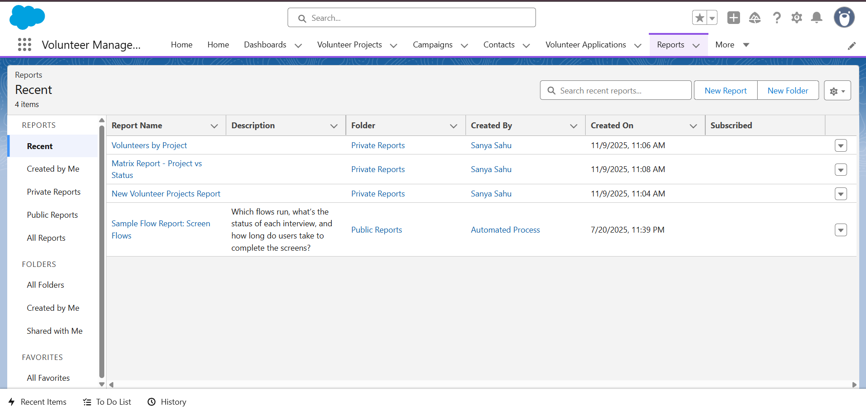

**Report Types**

* Custom Report Type: “Volunteer Applications with Projects”
  + Primary Object: Volunteer_Application__c
  + Related Object: Volunteer_Project__c
  + Fields included: Role, Hours, Status, Project Type

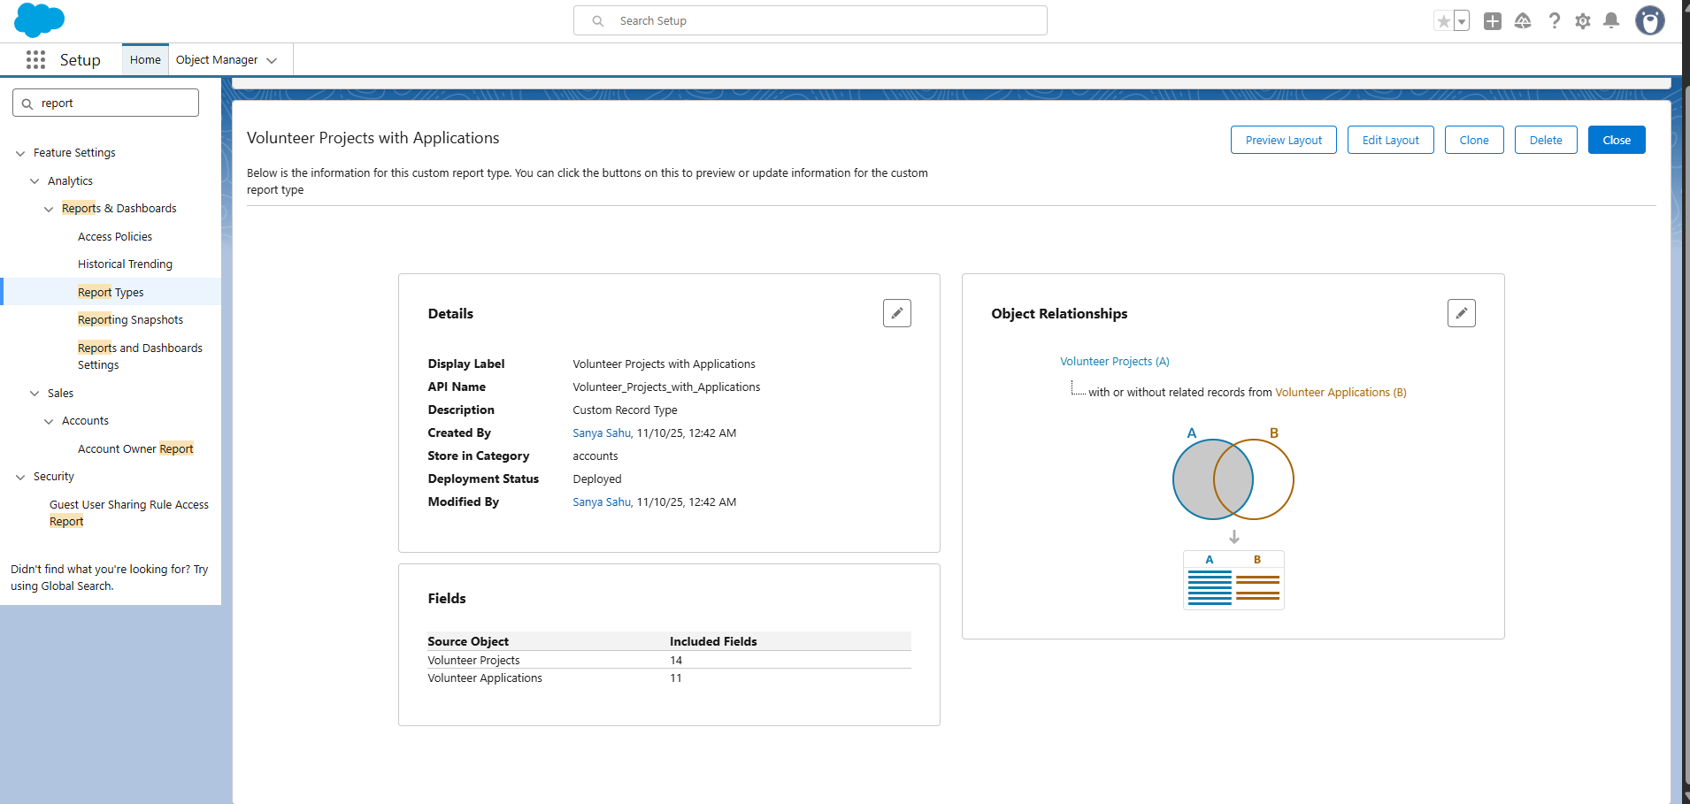

**Dashboards**

* Created Dashboard: “Volunteer Impact Overview”
* Components:
  + Total Volunteers (Metric)
  + Projects by Type (Pie Chart)
  + Hours Contributed per Volunteer (Bar Chart)
  + Project Status (Donut Chart)

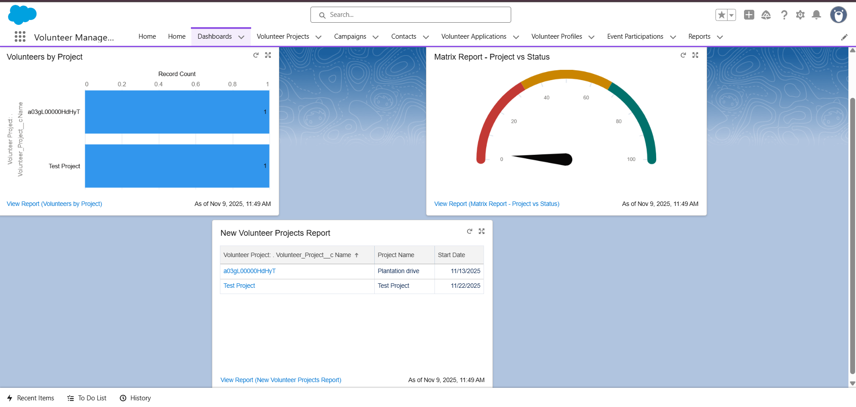

**Dynamic Dashboards**

* Configured “NGO Coordinator Dashboard” to view only their assigned projects.
* Set “View Dashboard As: Logged-In User” for dynamic data visibility.

**Sharing Settings**

* Path: Setup → Sharing Settings
* OWD:
  + Volunteer_Profile__c → Private
  + Volunteer_Application__c → Private
  + Volunteer_Project__c → Public Read Only
* Role Hierarchy: NGO Manager → Project Coordinator → Volunteer
* Sharing Rules: Coordinators can view volunteers in their projects.

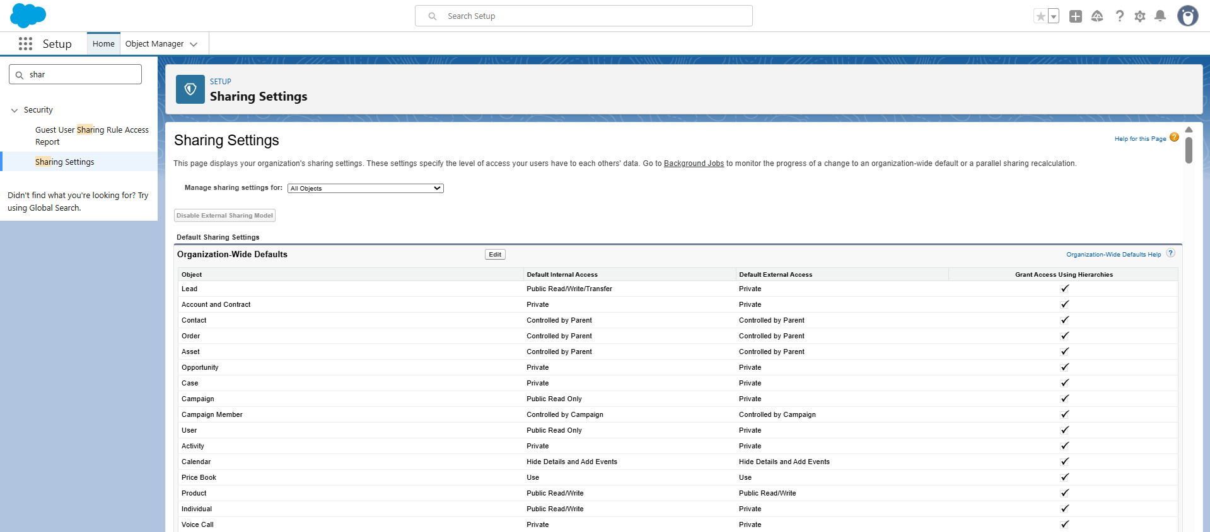

**Field-Level Security**

* Restricted sensitive fields (Phone, Email, ID Proof) for standard volunteers.
* Only Admins and Coordinators can edit or view these fields.
* “Hours Contributed” made read-only for volunteers.

**Session Settings**

* Path: Setup → Session Settings
* Timeout: 30 minutes inactivity
* Forced re-login after expiry
* Enabled: Clickjack protection and HTTPS secure browsing

**Login IP Ranges**

* Path: Setup → Profiles → System Administrator → Login IP Ranges
* IP Range Added:
  + Start: 182.70.151.100
  + End: 182.70.151.200
* Prevents unauthorized external login attempts.

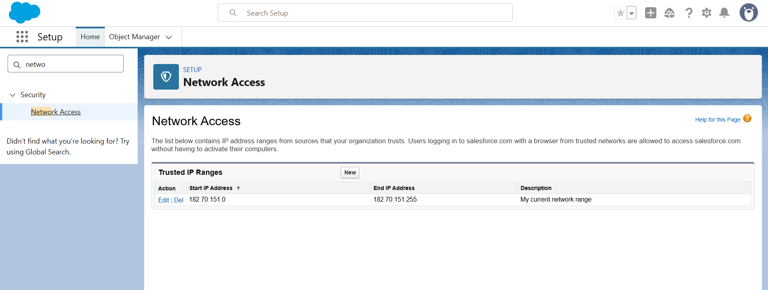

**Audit Trail**

* Path: Setup → View Setup Audit Trail
* Tracked last 6 months of configuration changes.
* Verified updates to objects, layouts, triggers, and dashboards.
* Ensured admin accountability and change tracking.

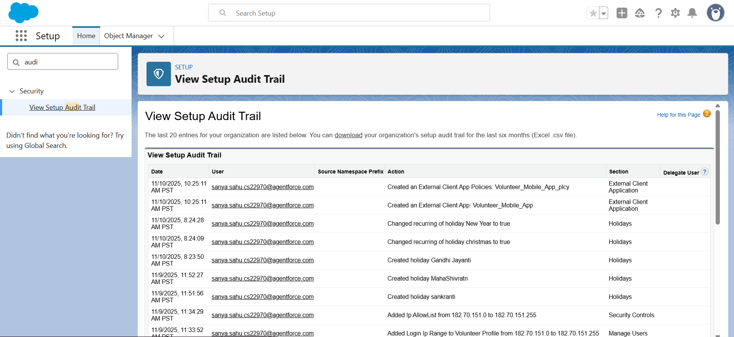

**Phase 10: Final Presentation & Demo Day**

**Demo Video Link:**

<https://drive.google.com/file/d/15l6A_bPbI-plqyn5c0eEAIfIVPOT24-P/view?usp=sharing>

**Some Screenshots of App:**

